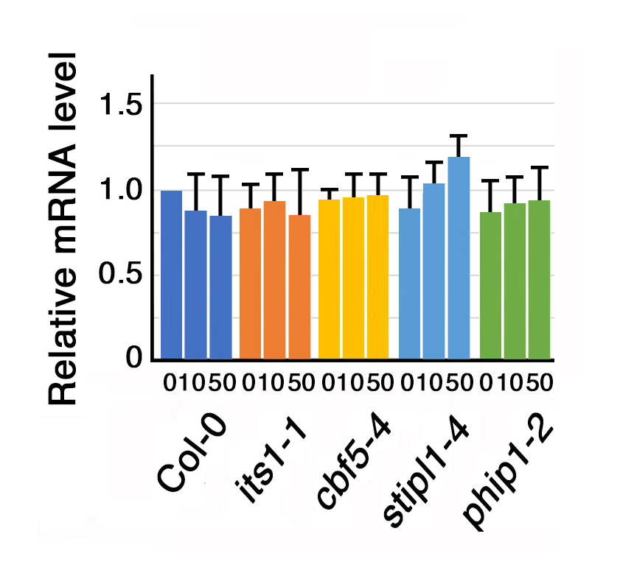

Figure S3. GUS mRNA levels in its1-1, cbf5-4, stipl1-4, and phip1-2, carrying the CaMV 35S promoter-SAC51 5’ leader-GUS fusion construct. qRT-PCR was performed using RNA prepared from Col-0 and each mutant seedling grown for 7 days with 0, 10, or 50 μM thermospermine. The GUS mRNA level was normalized to the ACT8 mRNA level and set to 1 in Col-0 without thermospermine. Values are means ± SE (n = 3).

