Supplementary Figure S1. COVID-19 infection rates in Japan

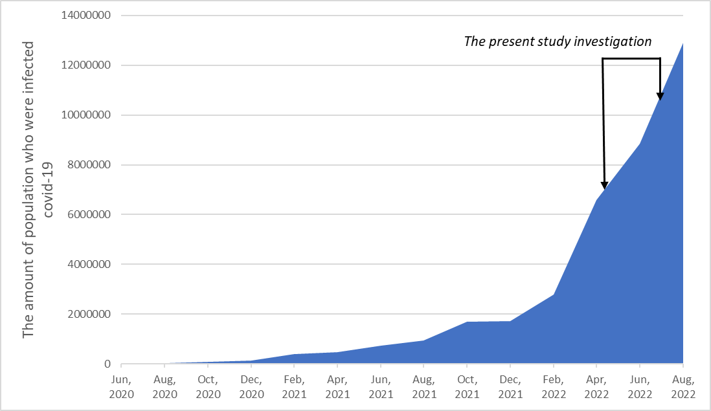
Note: The data was provided by the Ministry of Health, Labor and Welfare, Japan (https://covid19.mhlw.go.jp/en/).

Figure S2. The stability of general network estimations
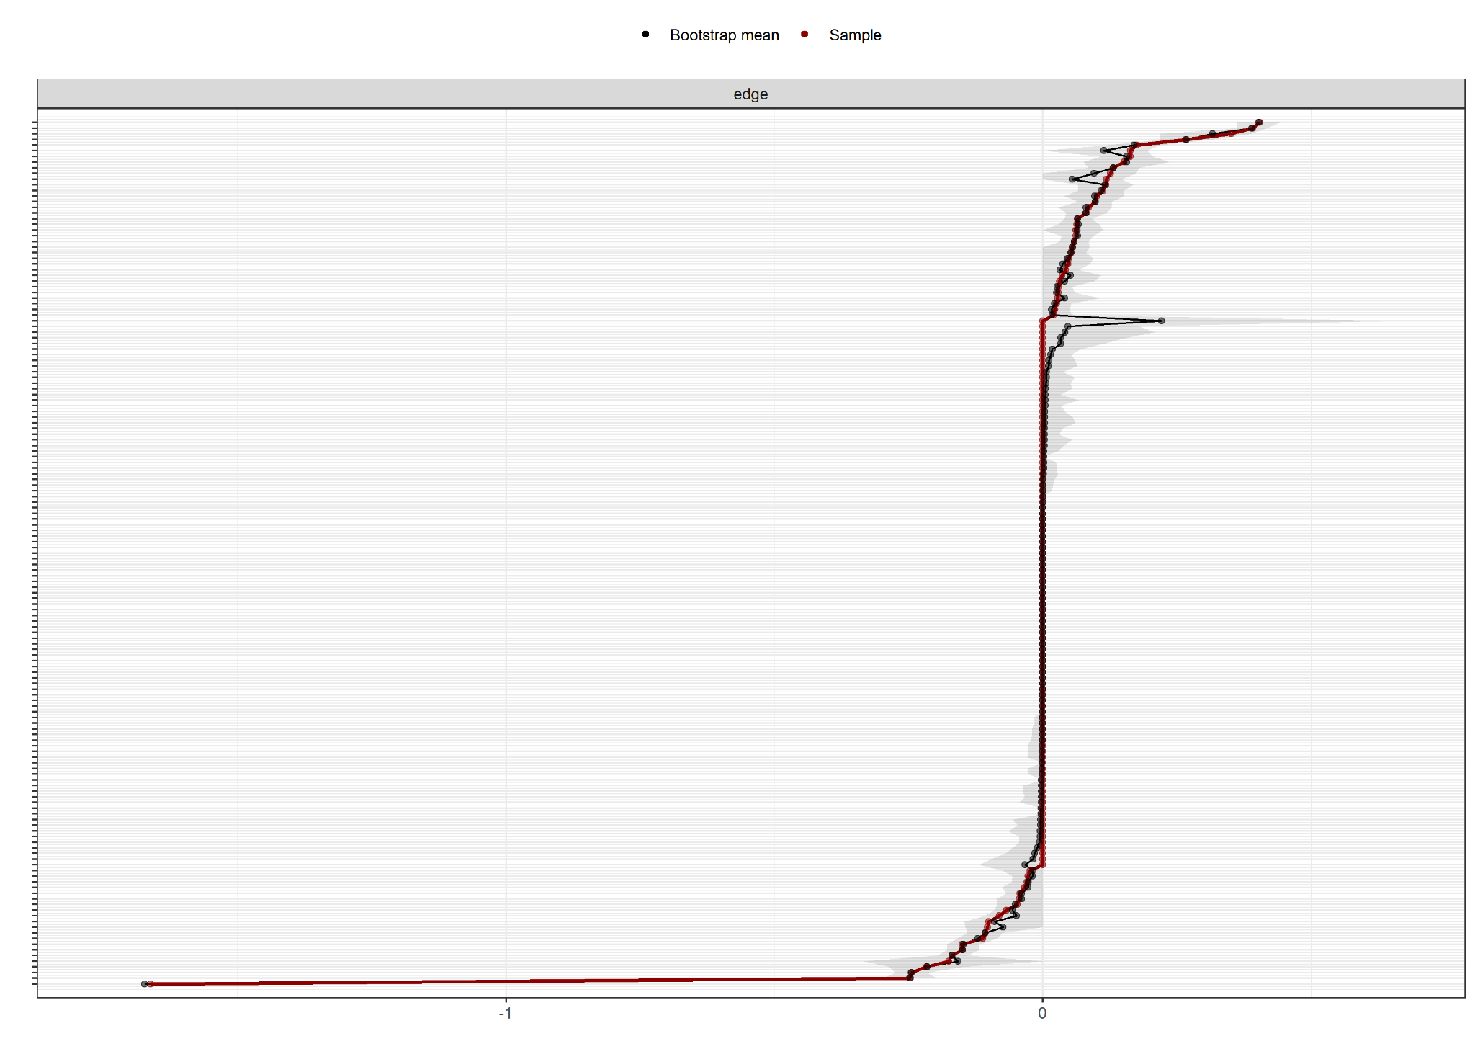

Note: The plot describes repetitive resampling results using bootstrap methods. The vertical axis means a certain edge, and the horizontal line is the weight of the coefficient. The gray areas are the weights of the coefficients estimated with 95% probability in the bootstrap, and most edges do not cross the 0 line, indicating a stable estimation of the general network.

