Original Article
Nationwide diversity of symbolic “city flowers” in Japan is increasing
Supporting Information Figures

Authors
Yoichi Tsuzuki†*^{ab}, Haruna Ohsaki†*^{cd}, Yawako W Kawaguchi†*^{efgh}, Sayaka Suzuki^{i}, Shogo Harada^{j}, Yurie Otake^{ik}, Naoto Shinohara^{ik}, Koki R Katsuhara^{l}
*Correspondence: tsuzukiyoichi@g.ecc.u-tokyo.ac.jp (YT), ohsakih@tmu.ac.jp (HO), yawako.clph@gmail.com (YWK, submitting author)
† These authors contributed equally

Affiliations
a. Health and Environmental Risk Division, National Institute for Environmental Studies, 16-2, Onogawa, Tsukuba, Ibaraki 305-8506, Japan
b. Institute for Sustainable Agro-ecosystem Services, Graduate School of Agricultural and Life Science, The University of Tokyo, 1-1-1, Midoricho, Nishitokyo, Tokyo 188-0002, Japan
c. Department of Biological Sciences, Tokyo Metropolitan University, 1-1 Minami-Osawa, Hachioji, Tokyo 192-0397, Japan
d. Department of Biological Sciences, Faculty of Agriculture and Life Science, Hirosaki University, 3. Bunkyo-cho, Hirosaki, Aomori 036-8561, Japan
e. Department of Biological Sciences, Graduate School of Science, The University of Tokyo, 7-3-1 Hongo, Bunkyo-ku, Tokyo 113-0033, Japan
f. Graduate School of Science and Engineering, Chiba University, 1-33 Yayoi-cho, Chiba 263-8522, Japan
g. Center for Frontier Research, National Institute of Genetics, 1111 Yata, Mishima, Shizuoka 411-8540, Japan
h. Department of Genomics and Evolutionary Biology, National Institute of Genetics, 1111 Yata, Mishima, Shizuoka 411-8540, Japan
i. Center for Ecological Research, Kyoto University, Hirano 2-509-3, Otsu, 520-2113 Shiga, Japan
j. Department of Biology, Graduate School of Science, Osaka City University, 3-3-138 Sugimoto Sumiyoshi-ku, Osaka-shi, 558-8585 Osaka, Japan
k. Graduate School of Life Sciences, Tohoku University, 2-1-1 Katahira, Aoba-Ku, 980-8577 Sendai, Japan
l. Graduate School of Environmental, Life, Natural Science and Technology, Okayama University, Tsushima-Naka 1-1-1, Kita-ku, Okayama 700-8530, Japan.

Current affiliations
Shogo Harada, Department of Biology, Graduate School of Science, Osaka Metropolitan University, 3-3-138 Sugimoto, Sumiyoshi-ku, Osaka-shi, 558-8585, Osaka, Japan

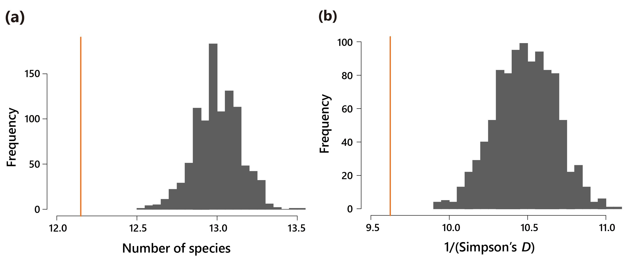
Fig. S1. Observed and simulated prefectural mean of species diversity. Orange lines indicate the observed mean of the number of species (a) and the Simpson’s D (b). Gray histograms indicate the simulated mean diversity obtained by randomly shuffling the prefecture names (1,000 times).

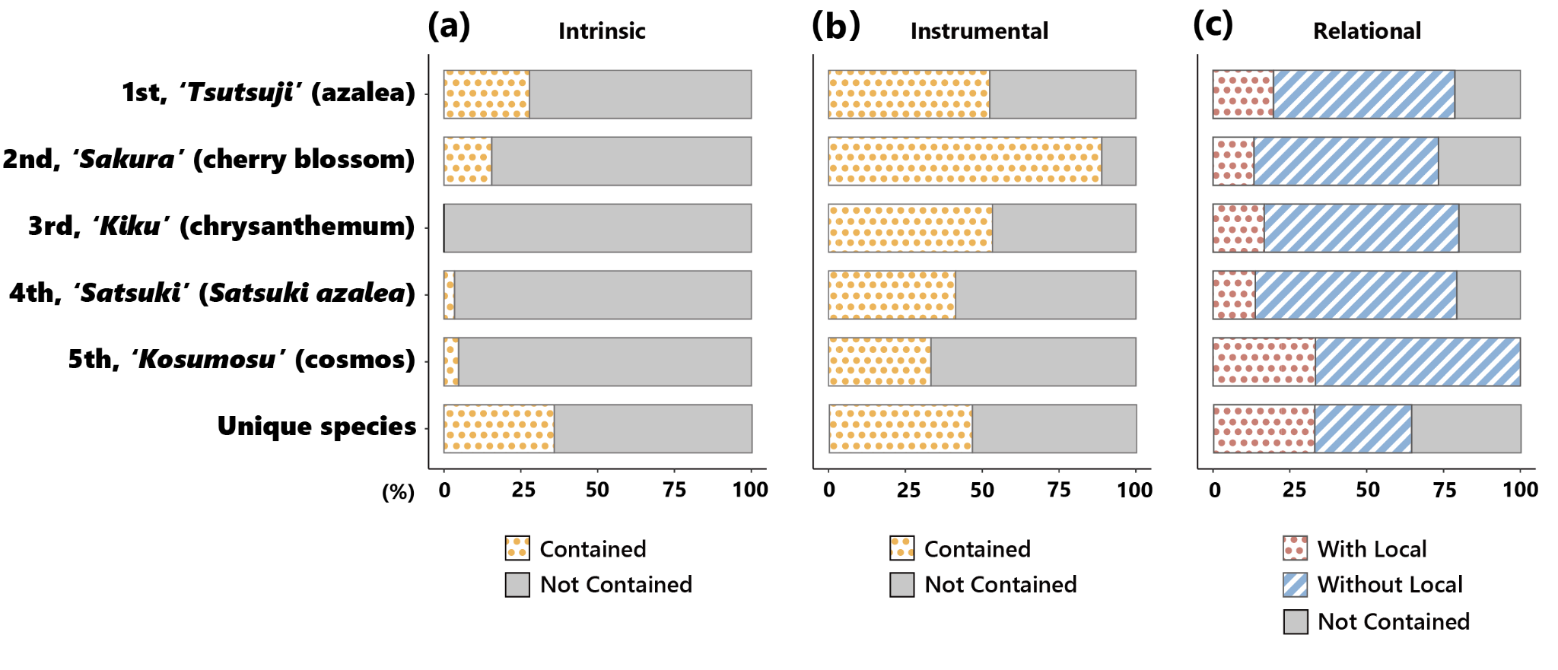
Fig. S2. Composition of reasons for adoption of the five most popular species and the unique species (see Table 1 for details on each reason category). The proportion of being adopted for the intrinsic (a) instrumental (b), and relational value (c).
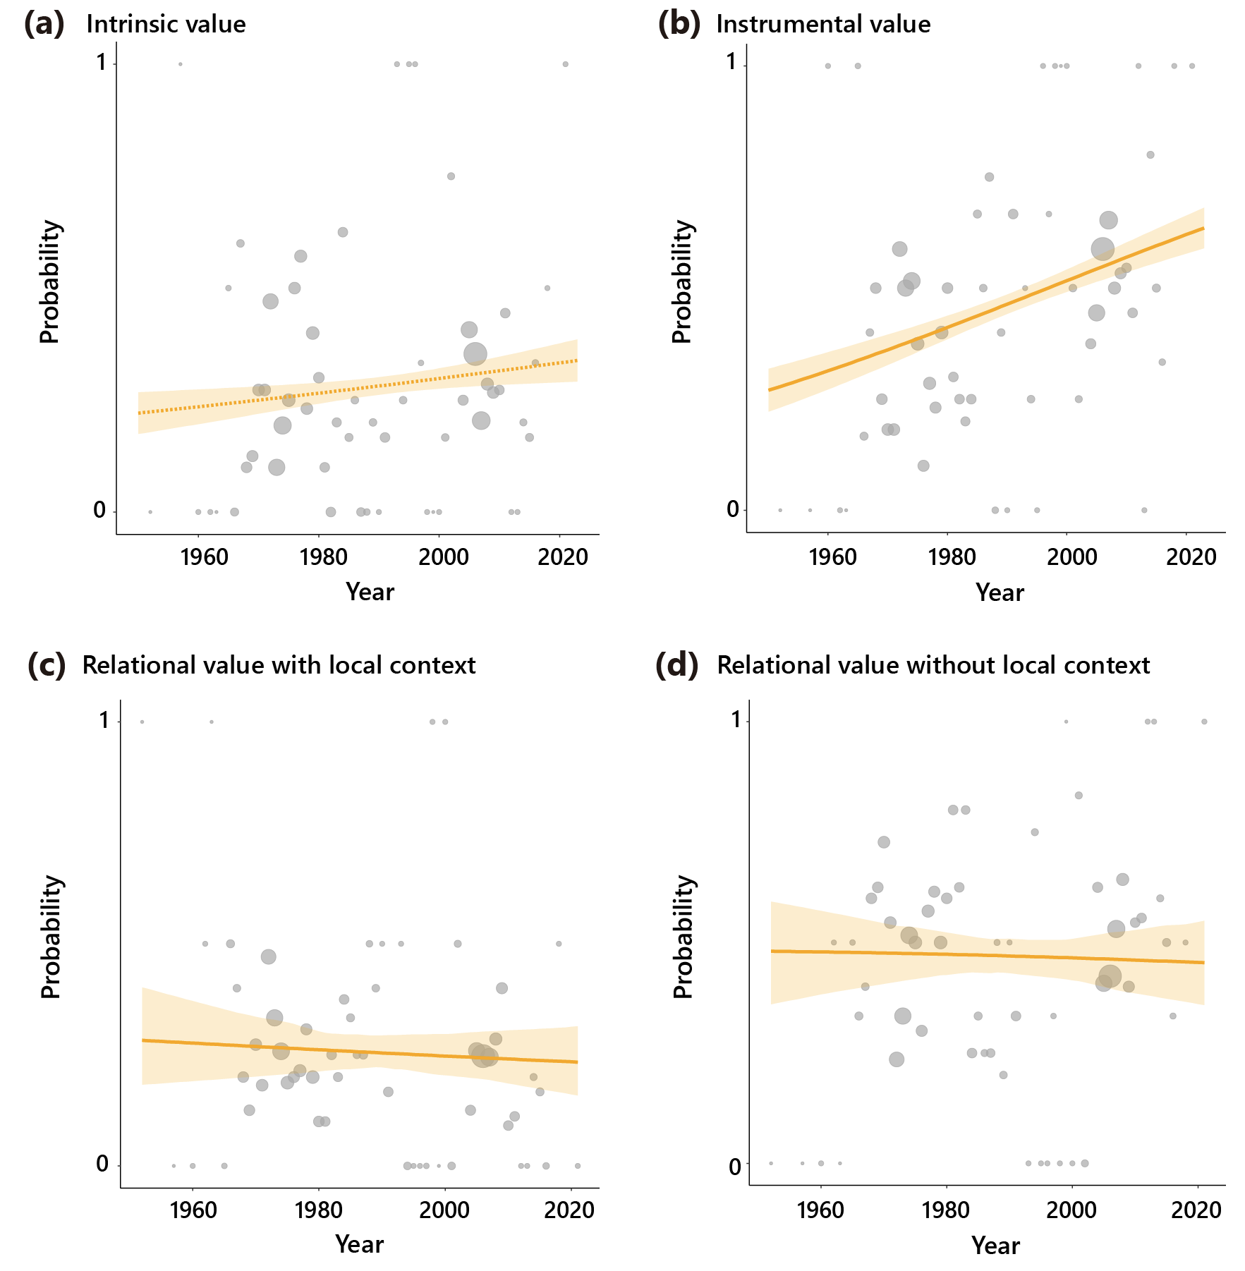

Fig. S3. Temporal trends in the probability of adopting a species for the intrinsic value (a), the instrumental value (b), and the relational value with and without local context (c and d). The circle size indicates the sample size. The orange solid and dotted regression lines, which were drawn based on generalized linear models, indicate significant (P < 0.05) and non-significant (P ≥ 0.05) effects of year, respectively, while the yellow-shaded areas indicate the 95% confidence intervals.

