Supporting information

Organic solvent transport through reduced graphene oxide membranes with controlled oxygen content

Hongzhe Chen ¹, Tongxi Lin ^{1’ *}, Zeno Rizqi Ramadhan², Aditya Rawal ³, Yuta Nishina ^{4,5}, Amir Karton ⁶, Xiaojun Ren ^{1, **}, Rakesh Joshi ^{1, ***}
¹ School of Materials Science and Engineering, University of New South Wales Sydney, NSW 2052, Australia
² Electron Microscope Unit, University of New South Wales, Sydney, NSW 2052, Australia
³ Mark Wainwright Analytical Centre, University of New South Wales, Kensington, NSW, 2052, Australia
⁴ Research Institute for Interdisciplinary Science, Okayama University, Kita-ku, Okayama 700-8530, Japan
⁵ Institute for Aqua Regeneration, Shinshu University, 4-17-1 Wakasato, Nagano 380-8553, Japan
⁶ School of Science and Technology, University of New England, Armidale, NSW 2351, Australia

*Corresponding author. E-mail: * tongxi.lin@student.unsw.edu.au
** xiaojun.ren@unsw.edu.au;*** r.joshi@unsw.edu.au

This file includes:
I. Supplementary Note 1 to 8
II. Supplementary Figures 1 to 8
III. Supplementary Tables 1 to 4

Supplementary Note 1. Experimental processes
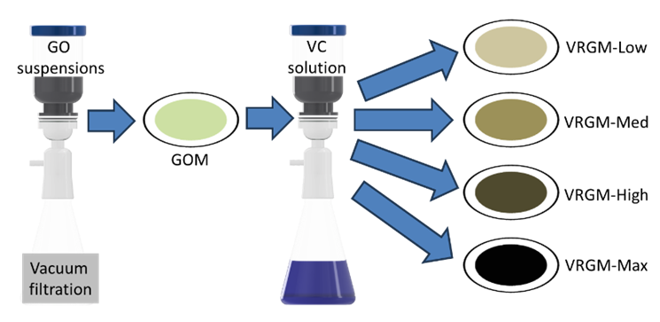
Figure S1. Schematic illustration of in-situ membrane-based reduction processes of VRGMs.
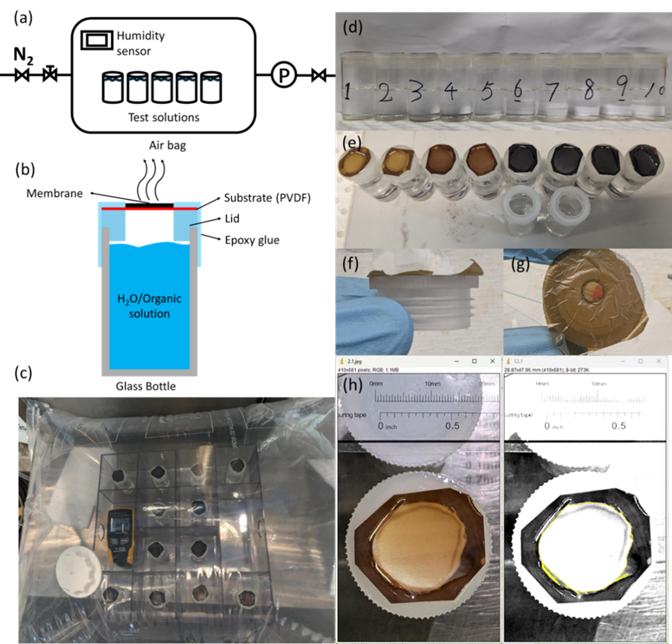
Figure S2. Schematic illustration of airbag system (a) and customized setup for vapor permeation measurement (b). Digital photograph of airbag system during vapor permeation measurement (c). Front view (d) and top view (e) of customized glass vials with solvents and membranes. Front view (f) and top view (g) of free-standing GOM on the lid of glass vial. (h) Screenshots of ImageJ program used for effective area measurements. The yellow line outlines the effective area.

The membrane photograph was processed using ImageJ, where the contrast and threshold were adjusted to an appropriate level, and the scale was calibrated using the scale bar in the photograph.

Table S1. Polarities and saturated vapor pressures of water and organic solvents[1–4].
Solvent | Polarity | Vapor pressure (kPa) | Kinetic diameter (Å)
Water | 1 | 2.3388 | 2.65
Ethanol | 0.654 | 5.95 | 4.46
DMSO | 0.444 | 0.0556 | 4.92
Acetone | 0.355 | 24.44 | 4.6
Chlorobenzen | 0.188 | 1.1999 | 5.9
Hexane | 0.009 | 17.6 | 4.3

Table S2. Detailed data of solvent permeances of GOM, VRGM-Med and VRGM-Max against oxygen contents.
Oxygen content  (atomic%) | 31.6 | 27.5 | 24
Solvent | Permeance  (µmol/h/mm²/kPa)
Water | 1.19 | 1.05 | 0.64944
Ethanol | 0.00938 | 0.00449 | 0.00352
DMSO | 0.20731 | 0.10795 | 0.10474
Acetone | 0.05207 | 0.05586 | 0.06914
CB | 0.01853 | 0.02943 | 0.07003
Hexane | 0.00424 | 0.00625 | 0.009

Supplementary Note 2. X-ray photoelectron spectroscopy (XPS)
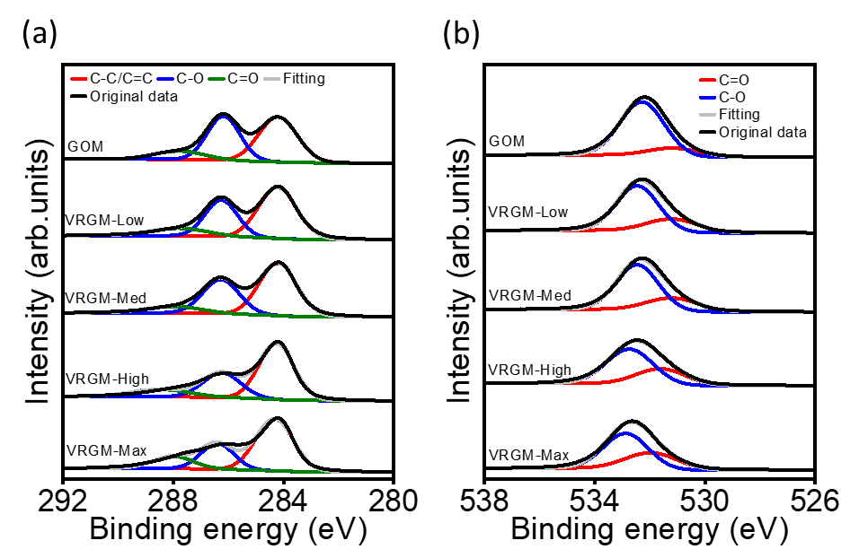
Figure S3. High-resolution XPS C1s (a) and O1s (b) spectra of GOM and VRGMs. XPS C1s spectra (black curve) showing C-C/C=C bond (red curve) at ~284.8 eV, C-O bond (blue curve) at ~286.7 eV and C=O bond (green curve) at ~288.1 eV. XPS O1s spectra (black curve) showing C=O (red curve) at ~531.3 eV and C-O (blue curve) at ~532.4 eV[5,6].

Table S3. The elemental composition of GOM and VRGMs deduced from XPS survey spectra and high resolution C1s and O1s spectra. The carbon to oxygen ratio (C/O ratio) is presented in atomic percentage.
Materials |  | GOM | VRGM-Low | VRGM-Med | VRGM-High | VRGM-Max
C/O ratio |  | 2.16 | 2.52 | 2.63 | 2.81 | 3.16
Oxygen content (atomic %) |  | 31.6 | 28.4 | 27.5 | 26.2 | 24.0
C1s (atomic %) | C-C/C=C | 48.4271 | 54.86079 | 55.18894 | 59.35658 | 61.20455
 | C-O | 40.067 | 33.0668 | 34.76873 | 27.90575 | 25.16537
 | C=O | 11.5059 | 12.07241 | 10.04233 | 12.73767 | 13.63008
O1s (atomic %) | C-O | 83.94315 | 73.36975 | 74.90842 | 66.88069 | 64.35713
 | C=O | 16.05685 | 26.63025 | 25.09158 | 33.11931 | 35.64287

Supplementary Note 3. Scanning electron microscopy (SEM)
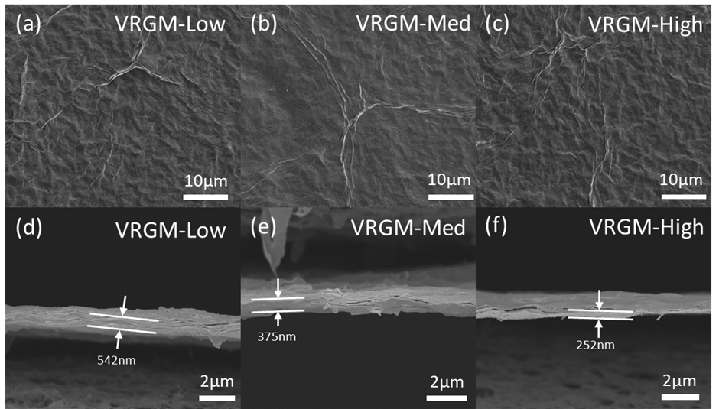
Figure S4. Surface SEM images of VRGM-Low (a), VRGM-Med (b), and VRGM-High (c). Cross-sectional SEM images of VRGM-Low (d), VRGM-Med (e) and VRGM-High (f). The white arrows indicate the thickness of the membranes[7].

Supplementary Note 4. Contact angle measurements
Figure S5. The contact angle of different organic solvents on GOM and VRGMs, the error bars represent the standard deviation.
The solvent wettability of the membrane surface can be characterized by the contact angle measurements. Figure S5 demonstrates the contact angle measurement results of GOM and VRGMs with water and organic solvents, the x-axis is sorted by solution polarity. The water contact angle of GOM is 41.53° and increases gradually to 63.51° of VRGM-Max, representing the increase of hydrophobicity of VRGMs due to the removal of hydrophilic oxygen functional groups. For organic solvents, the contact angle of ethanol cannot be detected in all studied membranes. Particularly, the hexane contact angles decrease from GOM to VRGM-Max.

Supplementary Note 5. X-ray diffraction (XRD)
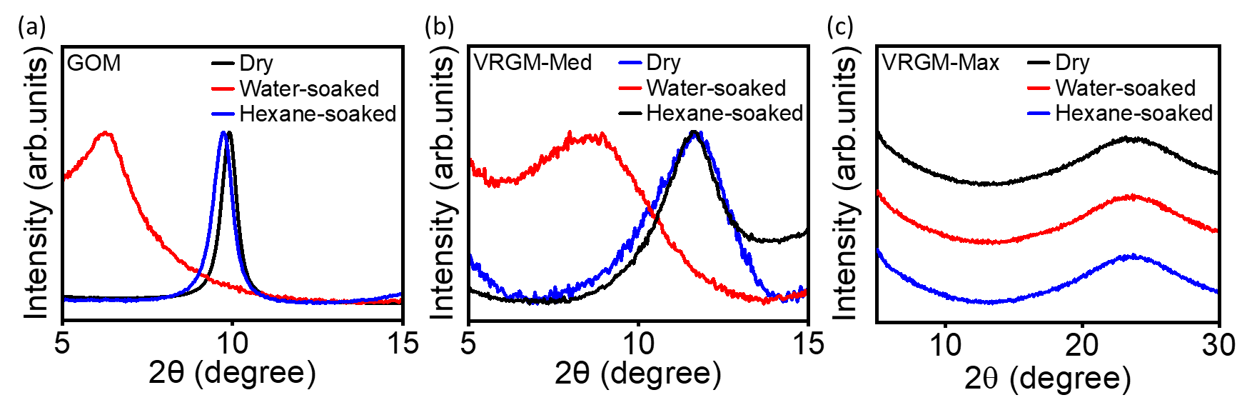
Figure S6. XRD patterns of GOM (a), VRGM-Med (b) and VRGM-Max (c) under dry, water-soaked, and hexane-soaked conditions.

Supplementary Note 6. Raman spectroscopy
Figure S7. Raman survey spectra from 1000 cm⁻¹ to 3500 cm⁻¹ of GOM and VRGMs. The peaks are D (~1340 cm⁻¹), G (~1605 cm⁻¹), 2D (~2680 cm⁻¹), and D+G (~2920 cm⁻¹), respectively[8,9].

The I_{D}/I_{G} ratio of GOM is 0.93. With the increase of VC concentrations, the I_{D}/I_{G} ratio increases from 1.07 for VRGM-Low to 1.39 for VRGM-Max. The A_{D’’} of GOM is 16%, followed by 12% of VRGM-Low, 10.54% of VRGM-Med, 9.53% of VRGM-High, and 7.43% of VRGM-Max, respectively.

Table S4. Fitting parameters calculated for GOM and VRGMs in the first order Raman spectra, x_{c} represents the peak position, w represents the peak FWHM of peak, A% represents the peak area in percentage.
Material |  | GOM | VRGM-Low | VRGM-Med | VRGM-High | VRGM-Max
D* (Lorentzian) | x_{c} (cm⁻¹) | 1195.2 | 1181.7 | 1180.7 | 1180.6 | 1180.7
D* (Lorentzian) | w (cm⁻¹) | 46.2 | 18.2 | 58.0 | 36.5 | 92.0
D* (Lorentzian) | A% | 0.6 | 0.2 | 1.0 | 0.4 | 2.6
D (Lorentzian) | x_{c} (cm⁻¹) | 1350.8 | 1347.1 | 1350.9 | 1345.3 | 1347.2
D (Lorentzian) | w (cm⁻¹) | 115.4 | 106.2 | 108.5 | 95.2 | 81.6
D (Lorentzian) | A% | 50.0 | 55.8 | 59.9 | 61.4 | 61.8
G (Lorentzian) | x_{c} (cm⁻¹) | 1586.3 | 1582.2 | 1590.8 | 1591.7 | 1590.8
G (Lorentzian) | w (cm⁻¹) | 80.0 | 60.0 | 59.6 | 56.0 | 48.5
G (Lorentzian) | A% | 27.1 | 19.4 | 24.1 | 24.0 | 21.2
D' (Lorentzian) | x_{c} (cm⁻¹) | 1613.8 | 1614.2 | 1620.8 | 1620.8 | 1620.7
D' (Lorentzian) | w (cm⁻¹) | 29.0 | 39.9 | 24.0 | 23.7 | 25.4
D' (Lorentzian) | A% | 5.3 | 11.7 | 4.5 | 4.6 | 7.0
D'' (Gaussian) | x_{c} (cm⁻¹) | 1520.0 | 1502.5 | 1535.3 | 1535.1 | 1536.2
D'' (Gaussian) | w (cm⁻¹) | 267.8 | 179.9 | 139.4 | 140.3 | 122.3
D'' (Gaussian) | A% | 16.9 | 12.9 | 10.5 | 9.6 | 7.4

Supplementary Note 7. Vapor permeation measurement
Figure S8. Water vapor permeance of GOM with PVDF substrate, bare PVDF substrate, free-standing GOM and open aperture (1 mm² effective area).

Supplementary Note 8. Computational details
We use density functional theory (DFT) calculations to examine the hydrogen bond interactions between oxygen functionalities on GO (epoxy and hydroxyl) and the oxygen-containing solvents considered in this work. We also examine the dispersion interactions between the graphitic domains of GO and the solvents n-hexane, chlorobenzene, DMSO, acetone, and ethanol. In these simulations we use C₅₄H₁₈ graphene nanoflakes to model the graphitic regions of GO and C₅₄H₁₈O (representing a central epoxy group) and C₅₄H₁₈OH (representing a central hydroxyl group). The geometries and harmonic vibrational frequencies of all structures have been obtained from DFT calculations at the PW6B95-D3BJ/def2-SVPP level of theory.[10,11] Empirical D3 dispersion corrections are included using the Becke–Johnson damping potential.[12,13] Zero-point vibrational energies (ZPVEs) and enthalpic temperature corrections (H₂₉₈–H₀). All the equilibrium structures and complexes were verified to have all real harmonic frequencies. The electronic energies were refined using the PWB95-D3BJ/def2-QZVPP level of theory.[10,11] All calculations were carried out using the Gaussian 16 rev. C.01 program suite.

References
[1] C. Reichardt, T. Welton, Solvents and Solvent Effects in Organic Chemistry, 1st ed., Wiley, 2010. https://doi.org/10.1002/9783527632220.
[2] S. Zheng, Q. Tu, M. Wang, J.J. Urban, B. Mi, Correlating Interlayer Spacing and Separation Capability of Graphene Oxide Membranes in Organic Solvents, ACS Nano 14 (2020) 6013–6023. https://doi.org/10.1021/acsnano.0c01550.
[3] W. Popendorf, Vapor Pressure and Solvent Vapor Hazards, American Industrial Hygiene Association Journal 45 (1984) 719–726. https://doi.org/10.1080/15298668491400494.
[4] Y. Yang, X. Yang, L. Liang, Y. Gao, H. Cheng, X. Li, M. Zou, R. Ma, Q. Yuan, X. Duan, Large-area graphene-nanomesh/carbon-nanotube hybrid membranes for ionic and molecular nanofiltration, Science 364 (2019) 1057–1062. https://doi.org/10.1126/science.aau5321.
[5] R. Al-Gaashani, A. Najjar, Y. Zakaria, S. Mansour, M.A. Atieh, XPS and structural studies of high quality graphene oxide and reduced graphene oxide prepared by different chemical oxidation methods, Ceramics International 45 (2019) 14439–14448. https://doi.org/10.1016/j.ceramint.2019.04.165.
[6] L. Stobinski, B. Lesiak, A. Malolepszy, M. Mazurkiewicz, B. Mierzwa, J. Zemek, P. Jiricek, I. Bieloshapka, Graphene oxide and reduced graphene oxide studied by the XRD, TEM and electron spectroscopy methods, Journal of Electron Spectroscopy and Related Phenomena 195 (2014) 145–154. https://doi.org/10.1016/j.elspec.2014.07.003.
[7] T. Lin, X. Ren, X. Wen, A. Karton, V. Quintano, R. Joshi, Membrane based In-situ reduction of graphene oxide for electrochemical supercapacitor application, Carbon 224 (2024) 119053. https://doi.org/10.1016/j.carbon.2024.119053.
[8] W. Gao, L.B. Alemany, L. Ci, P.M. Ajayan, New insights into the structure and reduction of graphite oxide, Nature Chem 1 (2009) 403–408. https://doi.org/10.1038/nchem.281.
[9] Y. Cao, Z. Xiong, F. Xia, G.V. Franks, L. Zu, X. Wang, Y. Hora, S. Mudie, Z. He, L. Qu, Y. Xing, D. Li, New Structural Insights into Densely Assembled Reduced Graphene Oxide Membranes, Adv Funct Materials 32 (2022) 2201535. https://doi.org/10.1002/adfm.202201535.
[10] Y. Zhao, D.G. Truhlar, Design of Density Functionals That Are Broadly Accurate for Thermochemistry, Thermochemical Kinetics, and Nonbonded Interactions, J. Phys. Chem. A 109 (2005) 5656–5667. https://doi.org/10.1021/jp050536c.
[11] F. Weigend, R. Ahlrichs, Balanced basis sets of split valence, triple zeta valence and quadruple zeta valence quality for H to Rn: Design and assessment of accuracy, Phys. Chem. Chem. Phys. 7 (2005) 3297. https://doi.org/10.1039/b508541a.
[12] S. Grimme, S. Ehrlich, L. Goerigk, Effect of the damping function in dispersion corrected density functional theory, J Comput Chem 32 (2011) 1456–1465. https://doi.org/10.1002/jcc.21759.
[13] A.D. Becke, E.R. Johnson, A density-functional model of the dispersion interaction, The Journal of Chemical Physics 123 (2005) 154101. https://doi.org/10.1063/1.2065267.

