Supporting Information for

Elucidation of the Relationship Between Solid-State Photoluminescence and Crystal Structures in 2,6-Substituted Naphthalene Derivatives

Minoru Yamaji,^{a,*} Isao Yoshikawa,^{b} Toshiki Mutai,^{c} Hirohiko Houjou,^{b,d} Kenta Goto,^{e} Fumito Tani,^{e} Kengo Suzuki^{f} and Hideki Okamoto^{g}

ª Department of Applied Chemistry, Division of Materials and Environment, Graduate School of Science and Engineering, Gunma University, Ota, Gunma 373-0057, Japan
^{b} Department of Materials and Environmental Science, Institute of Industrial Science, The University of Tokyo, Meguro, Tokyo 153-8505, Japan
^{c} Technology Transfer Service Corporation, Minato, Tokyo 107-6033, Japan
^{d} Environmental Science Center, The University of Tokyo, Bunkyo, Tokyo 113-0033, Japan
^{e} Institute for Materials Chemistry and Engineering, Kyushu University, Fukuoka 819-0395, Japan.
^{f} Hamamatsu Photonics K.K., Joko-cho, Hamamatsu, Shizuoka 431-3196, Japan
^{g} Department of Chemistry, Faculty of Environment, Life, Natural Sciences and Technology, Okayama University, Okayama 700-8530, Japan

Contents

P. 2 1. Materials, synthetic procedures and analytical data.

P. 4 2. ¹H and ¹³C NMR spectra of the synthesized naphthalene derivatives. (Figures S1-3)

P. 7 3. X-ray crystallographic analysis data of PhPyNp and DPyNp. (Table S1)

P. 8 4. Decay profiles of fluorescence of the DArNps in cyclohexane, acetonitrile and the solid
state. (Figures S4-6)

P. 9 5. Results of DFT and TD-DFT calculations of the DArNps; atom coordinates and sum of
electronic and zero-point energies in chloroform. (Tables S2-4)

P. 13 6. HOMO and LUMO surfaces of DArNps in the single crystal. (Figure S7)

P. 13 References

1. Materials, synthetic procedures and analytical data

1-1. Chemicals
Chloroform, acetonitrile and ethanol (spectroscopic grade from Wako) were used as solvents for the spectral measurements as supplied. The studied PhPyNp and DPyNp were prepared by the procedures described bellows whereas synthetic procedures were described in a previous paper.[1]

1-2-1. Synthesis of BrPyNp.

To a mixture of dimethoxyethane (10 ml) and H₂O (2 ml), dibromonaphthalene (1.0 mmol), 4-pyridyne boronic acid pinacol ester (2.4 mmol) and K₂CO₃ (690 mg, 5.0 mmol) were added, and the solution was bubbled with pure Ar for 10 min. After tetra(triphenylphosphinate)palladium (0) (120 mg, 10 % mol) was added, the solution was heated at 85 ℃ for 17 h. After cooling to room temperature, benzene (100 ml) was added. The solution was washed twice with brine (100 ml). Then, the organic layer was separated, and dried with Na₂SO₄. After the organic solvent was evaporated, the crude product was separated by silica gel chromatography with ethyl acetate as the eluent, and purified by recrystallization from ethyl acetate. Yield 52 %.

1-2-2. Synthesis of PhPyNp.

To a mixture of dimethoxyethane (10 ml) and H₂O (2 ml), BrPyNp (1.0 mmol), phenyl boronic acid (2.4 mmol) and K₂CO₃ (690 mg, 5.0 mmol) were added, and the solution was bubbled with pure Ar for 10 min. After tetra(triphenylphosphinate)palladium (0) (120 mg, 10 % mol) was added, the solution was heated at 85 ℃ for 3 h. After cooling to room temperature, benzene (100 ml) was added. The solution was washed twice with brine (100 ml). Then, the organic layer was separated, and dried with Na₂SO₄. After the organic solvent was evaporated, the crude product was separated by silica gel chromatography with ethyl acetate as the eluent, and purified by recrystallization from ethyl acetate. Yield 80 %.

1-3. Analytical data.
2-bromo-6-pyridylnaphthalene; BrPyNp: ¹H NMR (CDCl₃, 600 MHz) δ_{H} 8.76–8.68 (m, 2H), 8.10–8.02 (m, 2H), 7.90–7.83 (m, 1H), 7.82–7.73 (m, 2H), 7.64–7.58 (m, 3H).
¹³C NMR (CDCl₃, 151 MHz) δ_{C} 150.55, 147.94, 136.01, 134.51, 132.01, 130.30, 130.17, 129.95, 128.18, 126.48, 125.77, 121.90, 121.02.
HRMS (FAB) m/z calcd. for C₁₅H₁₀Br 284.0075, found 284.0075.
Rf on silica TLC developed with ethyl acetate: 0.42.

2,6-phenylpyridylnaphthalene; PhPyNp: ¹H NMR (CDCl₃, 600 MHz) δ_{H} 8.73–8.71 (m, 2H), 8.15 (brs, 1H), 9.08 (brs, 1 H), 8.02 (t, 2H, J = 7.9 Hz), 8.83 (dd, 1H, J = 8.3, 1.7 Hz), 7.79 (dd, 1H, J = 8.4, 1.7 Hz), 7.77–7.73 (m, 2H), 7.68–7.64 (m, 2H), 7.51 (m, 2H), 7.54–7.49 (m, 2H), 7.43–7.39 (m, 1H).
¹³C NMR (CDCl₃, 151 MHz) δ_{C} 150.52, 148.34, 140.90, 139.72, 135.56, 133.86, 132.78, 129.40, 129.13, 129.10, 127.79, 127.57, 126.63, 126.34, 125.71, 125.13, 121.94.
HRMS (FAB) m/z calcd. for C₂₁H₁₅N 281.1204, found 281.1204.
Rf on silica TLC developed with ethyl acetate: 0.22.

2,6-Dipyridylnaphthalene; DPyNp: ¹H NMR (600 MHz, CDCl₃) δ_{H} 8.72 (m, 4H), 8.17 (m, 2H), 8.05 (d, 2H, J = 8.4 Hz), 7.82 (dd, 2H, J = 8.4, 1.4 Hz), 7.66 (m, 4H).
¹³C NMR (151 MHz, CDCl₃) δ_{C} 150.54, 148.11, 136.53, 133.63, 129.67, 126.39, 125.60, 121.98. The obtained data was identical with those reported previously [2].

2. ¹H and ¹³C NMR spectra of the synthesized naphthalene derivatives.

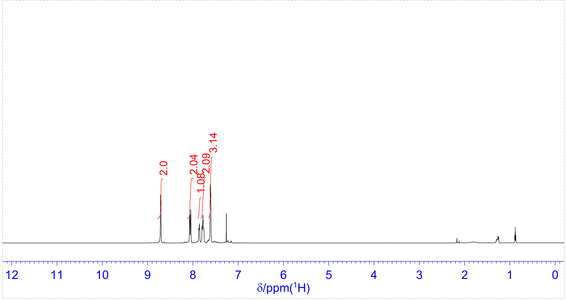

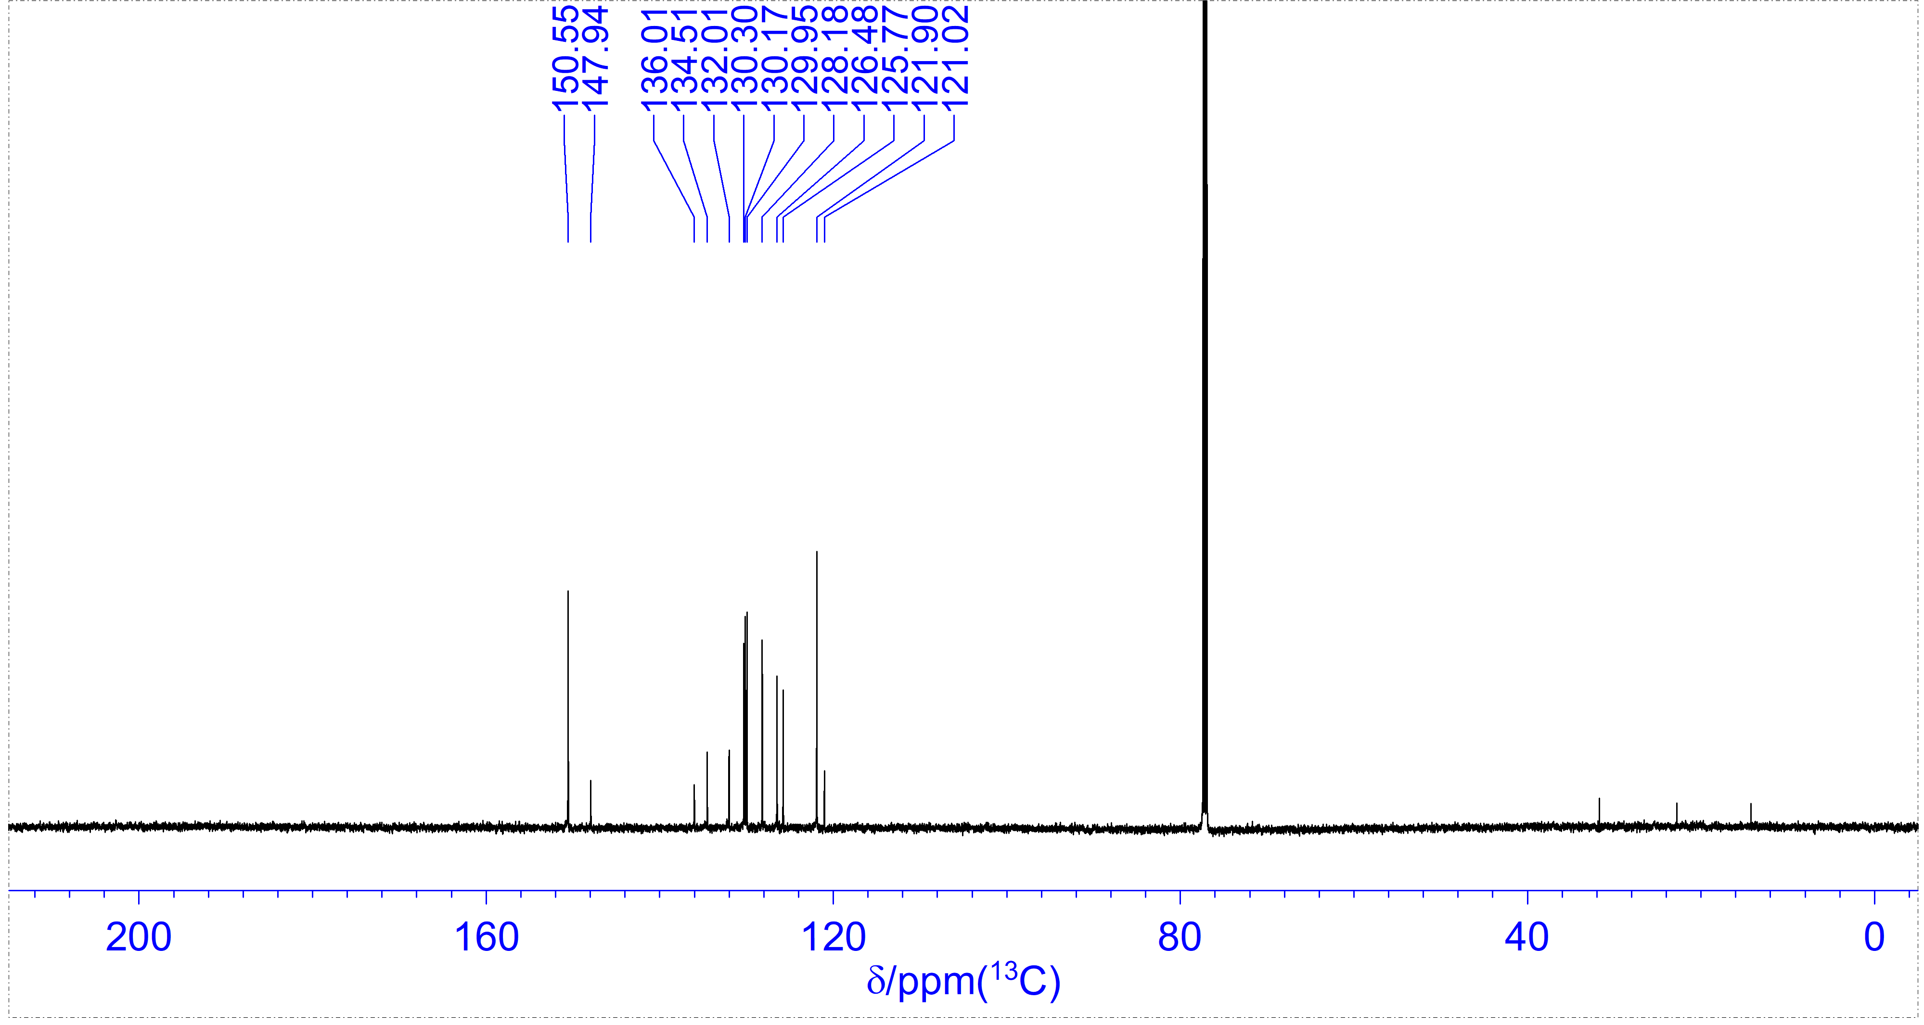

Fig. S1 ¹H (600 MHz, CDCl₃, upper) and ¹³C (151 MHz, CDCl₃, lower) NMR spectra of BrPyNp.

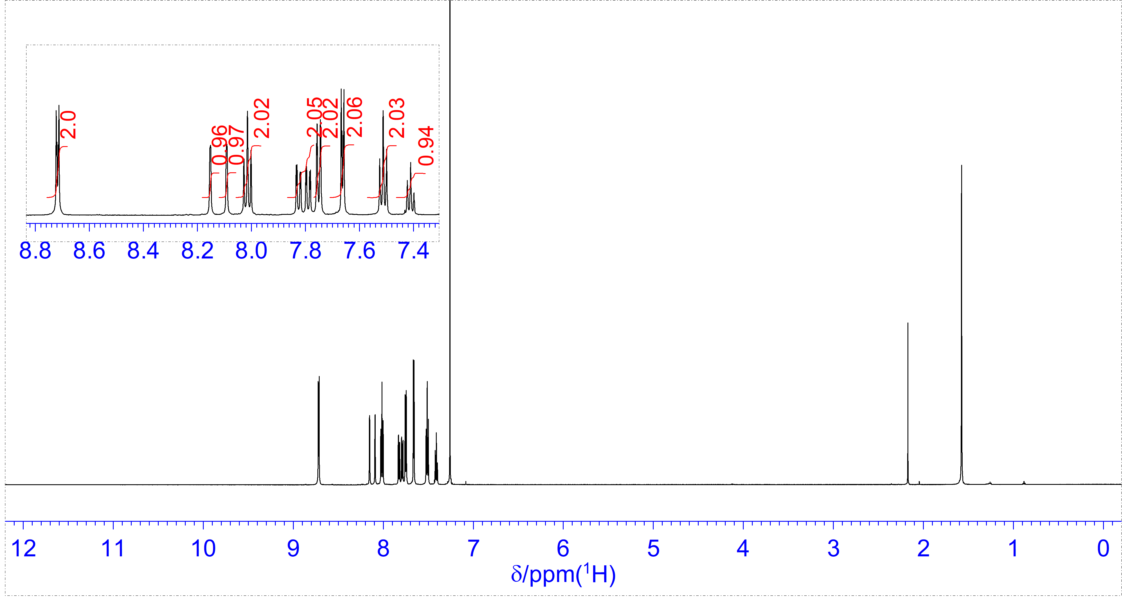

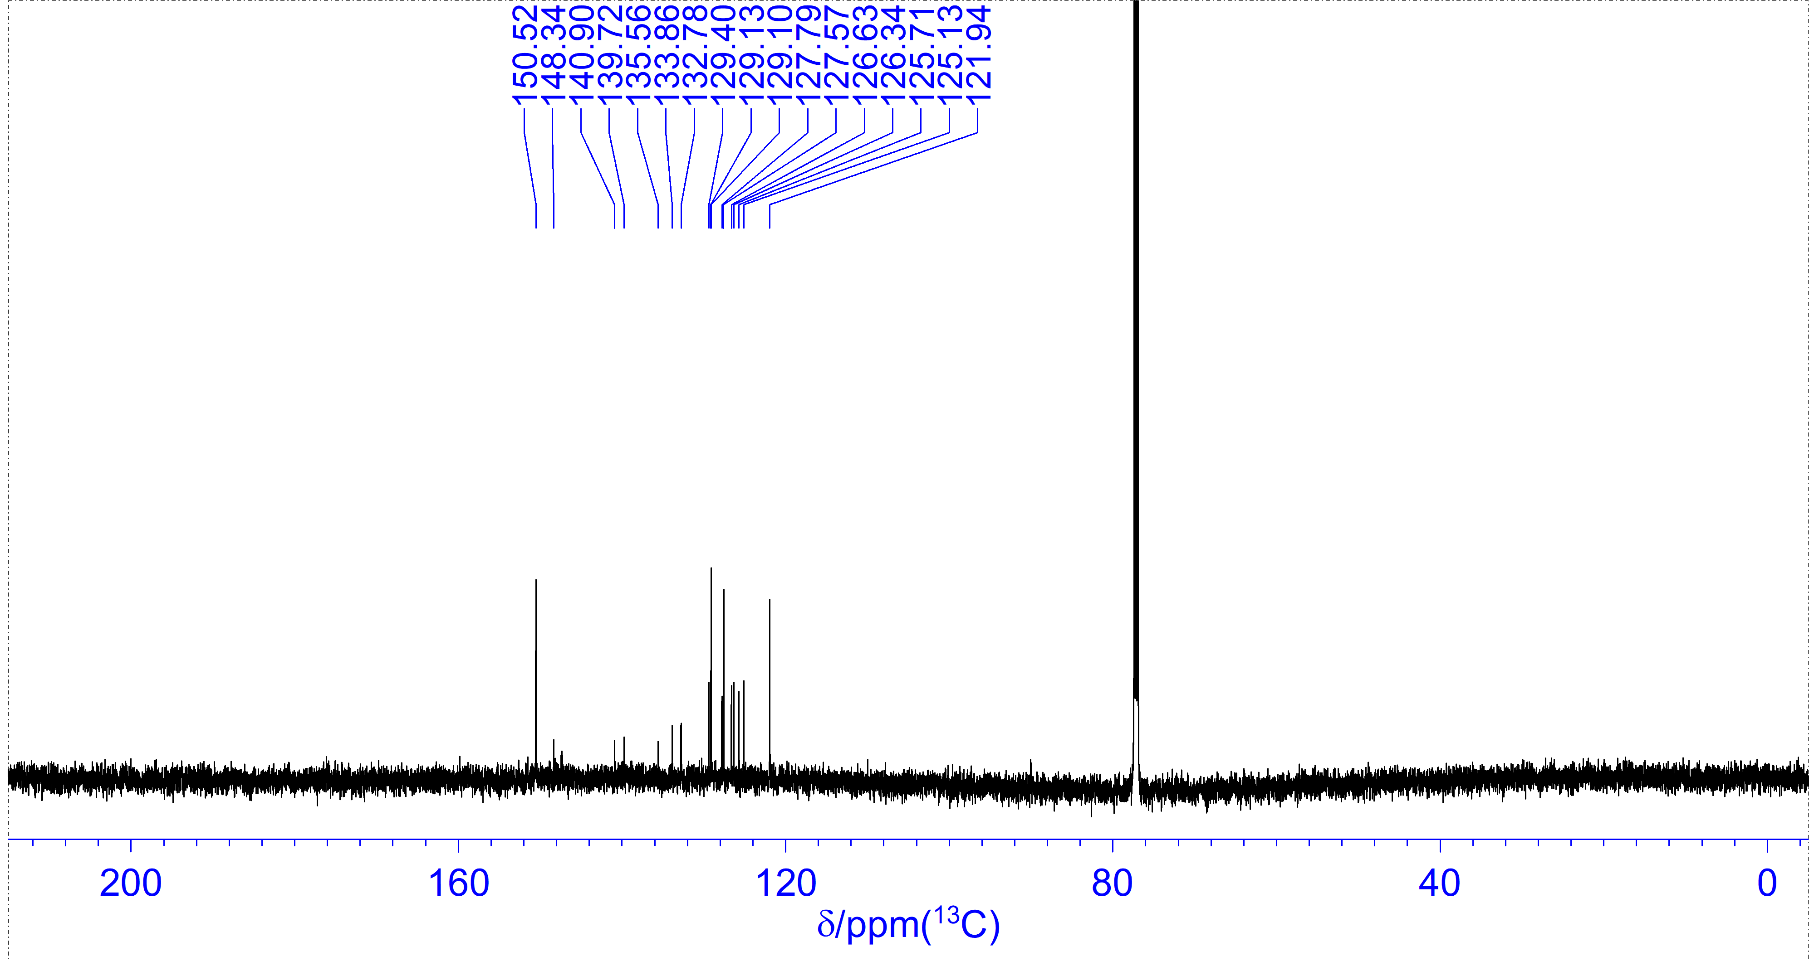

Fig. S2 ¹H (600 MHz, CDCl₃, upper) and ¹³C (151 MHz, CDCl₃, lower) NMR spectrum of PhPyNp.

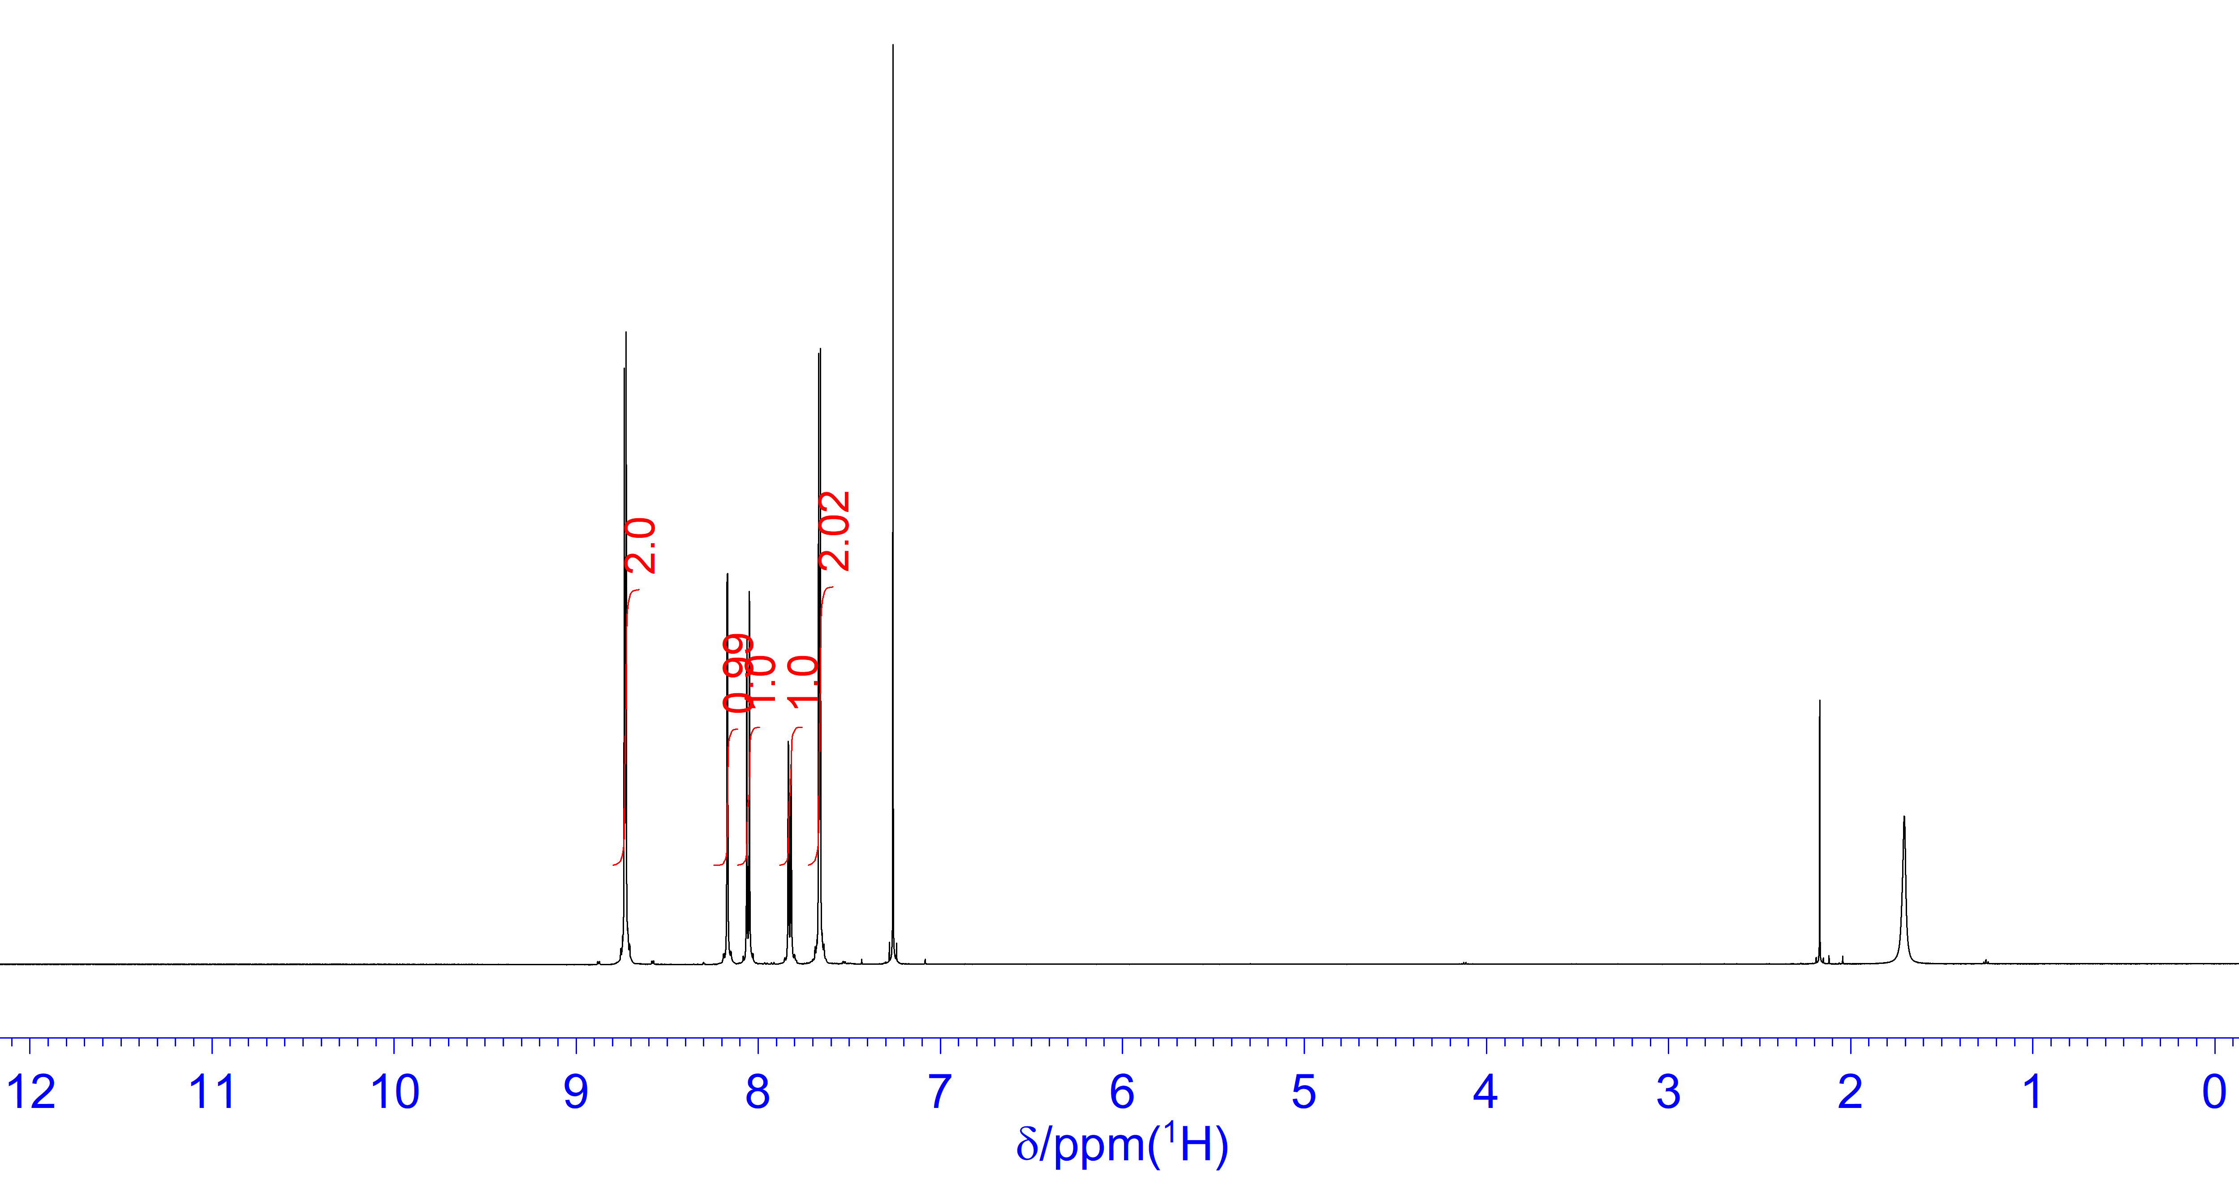

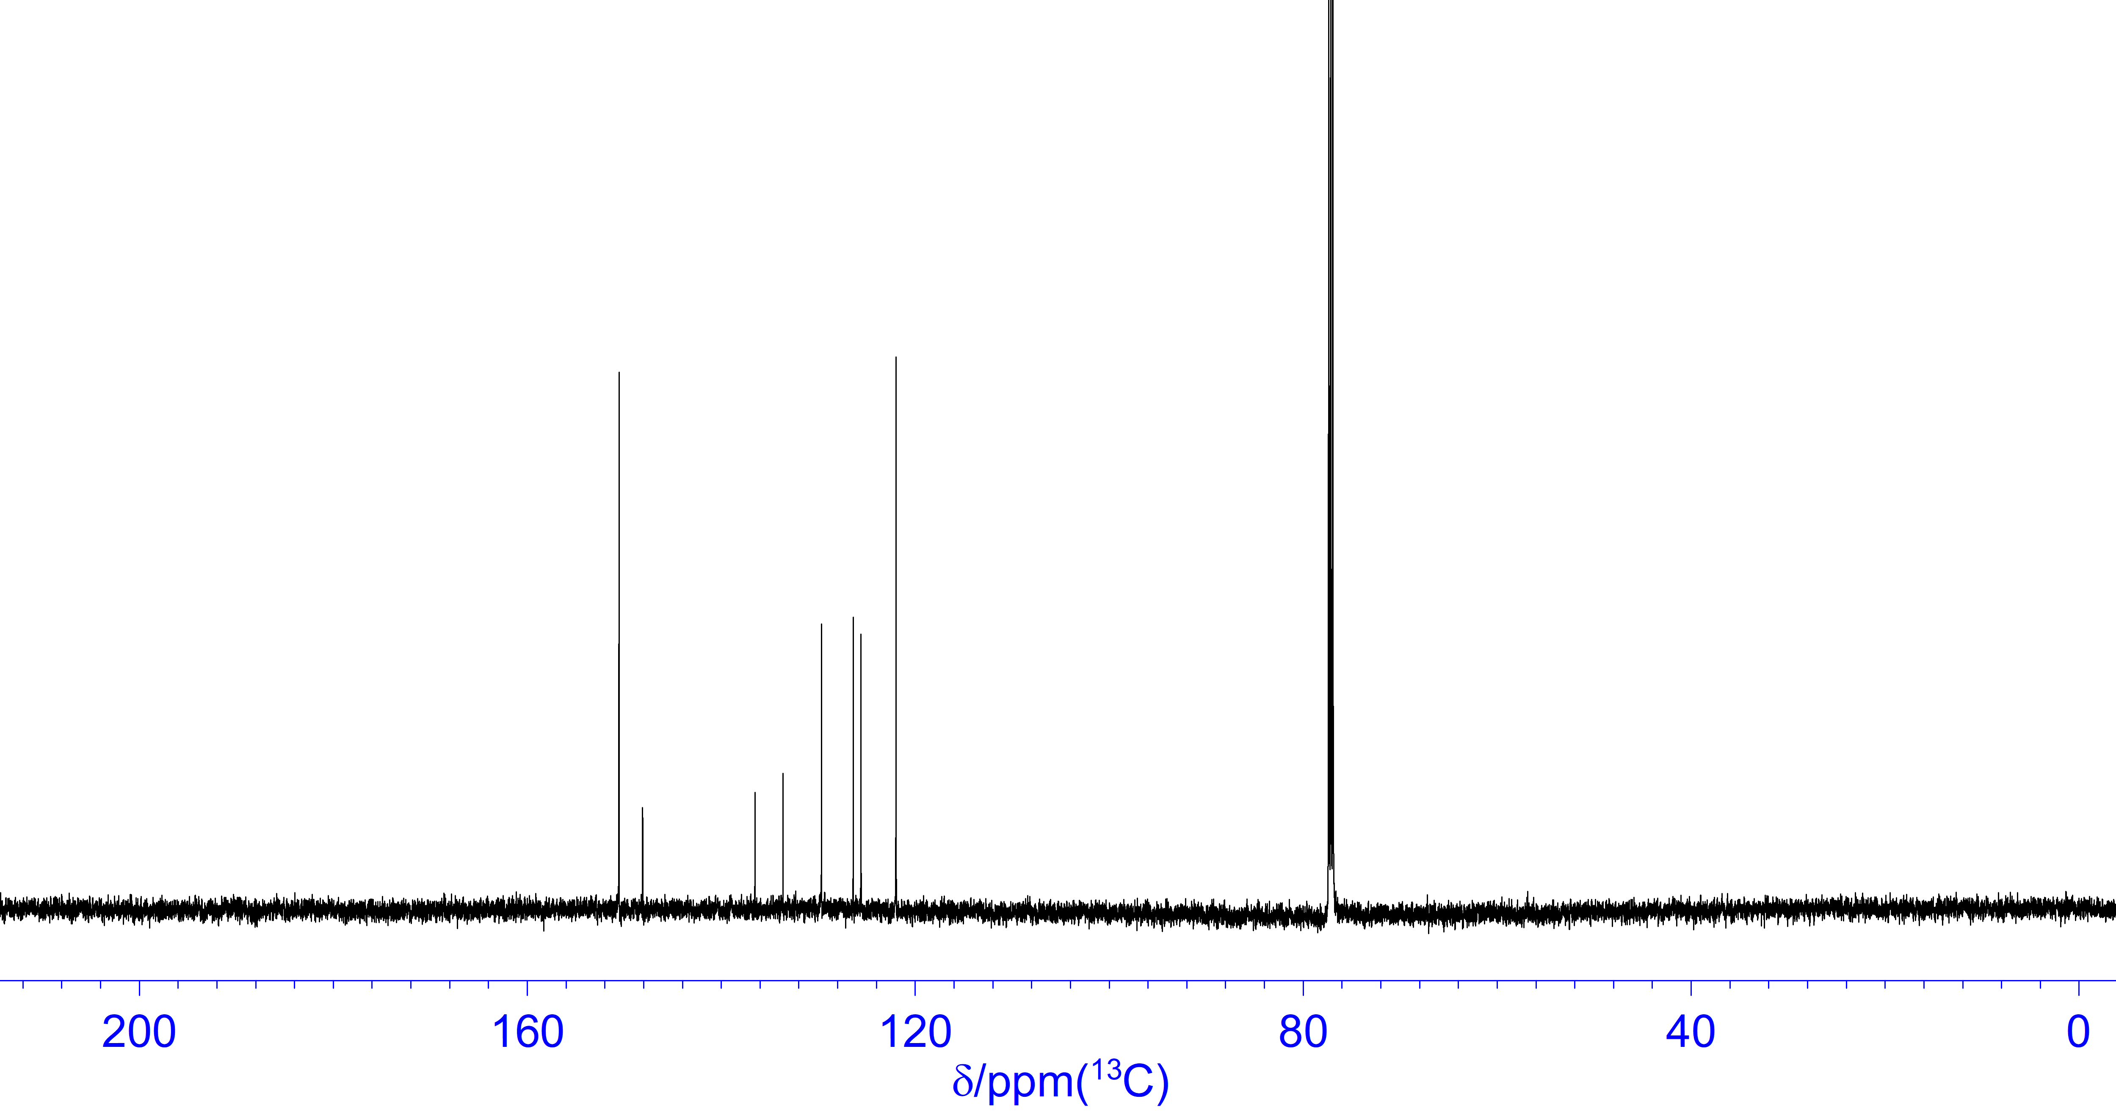

Fig. S3 ¹H (600 MHz, CDCl₃, upper) and ¹³C (151 MHz, CDCl₃, lower) NMR spectra of DPyNp.

3. X-ray crystallographic analysis data of PhPyNp and DPyNp

Crystallographic data of the studied PhPyNp and DPyNp are listed in Table S1. The structures were solved by direct methods (shelxs-2013)[3] and refined on F² by full-matrix least-squares techniques (shelxl-2018)[4] using the Yadokari- XG software package.[5] All non-hydrogen atoms were refined anisotropically; hydrogen atoms were refined isotropically, whereby hydrogen positions are based on stereochemical considerations.

Table S1 Crystallographic data of compounds PhPyNp and DPyNp
Compound | PhPyNp  CCDC 2452168 | DPyNp  CCDC 2452169
Empirical formula (FW) | C₂₁H₁₅N (281.34) | C₂₀H₁₄N₂ (282.33)
Crystal dimensions | 0.20 x 0.20 x 0.01 mm³ | 0.25 x 0.15 x 0.03 mm³
Crystal system | orthorhombic | orthorhombic
a | 5.9699(5) Å | 6.9315(1) Å
b | 7.4311(5) Å | 10.5681(3) Å
c | 31.359(2) Å | 18.6878(5) Å
α | 90 ° | 90 °
β | 90 ° | 90 °
γ | 90° | 90 °
V | 1391.19(18) Å³ | 1368.93(6) Å³
Space group | P2₁2₁2₁ | Pbca
Z | 4 | 4
Z’ | 1 | 0.5
ρ_{calcd} | 1.343 g/cm³ | 1.370 g/cm³
F(000) | 592.0 | 592.0
μ(CuKα) | 0.595 mm⁻¹ | 0.629 mm⁻¹
2θ_{max} | 145.488 ° | 145.762 °
Obs. Temp. | 100 K | 93 K
Total reflections measured | Total: 12610  Unique: 2700  (R_{int} = 0.1001) | Total: 7307  Unique: 1353  (R_{int} = 0.0254)
Number of parameters | 200 | 100
Data/parameter ratio | 13.5 | 13.5
R₁ (I>2.00σ(I)) | 0.1410 (2199) | 0.0390 (1258)
wR2  (All reflections) | 0.3813(2700) | 0.1062 (1353)
GOF | 1.627 | 1.078
Max/min residual density | 0.984 / -0.460 e⁻ Å³ | 0.191 / -0.290 e⁻ Å³

4. Decay profiles of fluorescence of the DArNps in chroroform, acetonitrile and the solid state.

Fig. S4 shows decay profiles of fluorescence for DArNps in chloroform.

Fig. S4 Decay profiles of fluorescence for DArNps in chloroform at 295 K. Ex and Mon in the figures indicate the excitation and monitoring wavelengths, respectively.

Fig. S5 shows decay profiles of PhPyNp and DPyNp in acetonitrile.

Fig. S5 Decay profiles of fluorescence for PhPyNp and DPyNp in acetonitrile at 295 K. Ex and Mon in the figures indicate the excitation and monitoring wavelengths, respectively.

Fig. S6 shows decay profiles for PhPyNp and DPyNp in the solid state.

Fig. S6 Decay profiles of fluorescence for PhPyNp and DPyNp in the solid state at 295 K. Ex and Mon in the figures indicate the excitation and monitoring wavelengths, respectively.

5. Results of DFT and TD-DFT calculations of the DPNs; atom coordinates and sum of electronic and zero-point energies in chloroform.

The calculation was carried out at the DFT level, using the Gaussian 09 software package [6]. The geometries of DPNs were fully optimized by using the 6-31+G(d,p) base set at the B3LYP method. Atom coordinates for the optimized geometries of DArNps in chloroform are as follows.

Table S2 Atom coordinates for the optimized geometry of DPhNp.
Atom | X | Y | Z
C | 4.858915 | -1.122514 | 0.400258
C | 6.244873 | -0.959027 | 0.454184
C | 6.827371 | 0.252454 | 0.068945
C | 6.009724 | 1.297957 | -0.371772
C | 4.624130 | 1.133430 | -0.426391
C | -4.858902 | 1.122637 | -0.399977
C | -6.244884 | 0.959194 | -0.453864
C | -6.827373 | -0.252370 | -0.068919
C | -6.009724 | -1.298029 | 0.371430
C | -4.624134 | -1.133543 | 0.426033
C | 4.022926 | -0.078654 | -0.038467
C | -4.022936 | 0.078646 | 0.038446
C | -0.616363 | 1.682694 | 0.540821
C | -1.979727 | 1.501361 | 0.486531
C | -2.547165 | 0.252345 | 0.089350
C | -1.687844 | -0.783840 | -0.245933
C | 0.616362 | -1.682727 | -0.540760
C | 1.979728 | -1.501426 | -0.486419
C | 2.547187 | -0.252395 | -0.089336
C | 0.277645 | 0.629557 | 0.198463
C | -0.277648 | -0.629567 | -0.198501
C | 1.687840 | 0.783823 | 0.245859
H | 4.420885 | -2.062367 | 0.722956
H | 6.868554 | -1.776607 | 0.804384
H | 7.905168 | 0.379547 | 0.109272
H | 6.451052 | 2.240231 | -0.683955
H | 4.004437 | 1.945335 | -0.795164
H | -4.420912 | 2.062568 | -0.722485
H | -6.868520 | 1.776935 | -0.803760
H | -7.905173 | -0.379466 | -0.109160
H | -6.451045 | -2.240421 | 0.683269
H | -4.004437 | -1.945594 | 0.794484
H | -0.207061 | 2.638828 | 0.856583
H | -2.638418 | 2.315482 | 0.772858
H | -2.090358 | -1.737873 | -0.575543
H | 0.207031 | -2.638867 | -0.856482
H | 2.638409 | -2.315620 | -0.772585
H | 2.090371 | 1.737856 | 0.575439
Sum of electronic and zero-point energies = -847.927230874 Hartree

Table S3 Atom coordinates for the optimized geometry of PhPyNp.
Atom | X | Y | Z
C | -1.982159 | 1.581541 | 0.019808
C | -2.546838 | 0.270657 | -0.002265
C | -1.691655 | -0.821184 | -0.017386
C | -0.281799 | -0.660582 | -0.012025
C | 0.273412 | 0.659526 | 0.002670
C | -0.618829 | 1.768416 | 0.019527
C | 0.610161 | -1.769552 | -0.017169
C | 1.973451 | -1.581365 | -0.013767
C | 2.540626 | -0.271007 | -0.004677
C | 1.683511 | 0.819581 | 0.006004
C | 4.016110 | -0.089204 | -0.002851
C | -4.019649 | 0.088170 | -0.002284
C | -4.869176 | 0.936268 | 0.727849
C | -6.246699 | 0.719187 | 0.700574
N | -6.835596 | -0.267745 | 0.006630
C | -6.023865 | -1.076872 | -0.693317
C | -4.636744 | -0.942206 | -0.731634
C | 4.851091 | -0.955823 | 0.726362
C | 6.236465 | -0.779350 | 0.733182
C | 6.817723 | 0.266168 | 0.008822
C | 6.000265 | 1.132866 | -0.723455
C | 4.615222 | 0.955529 | -0.730750
H | -2.640588 | 2.444391 | 0.009564
H | -2.095222 | -1.829901 | -0.008277
H | -0.207714 | 2.774407 | 0.022397
H | 0.198952 | -2.775366 | -0.036378
H | 2.632705 | -2.443536 | -0.041085
H | 2.087690 | 1.827676 | 0.037980
H | -4.468219 | 1.743870 | 1.331590
H | -6.909060 | 1.367992 | 1.269357
H | -6.507837 | -1.869577 | -1.259488
H | -4.049886 | -1.619803 | -1.343005
H | 4.413205 | -1.760664 | 1.309628
H | 6.861064 | -1.454700 | 1.310921
H | 7.895228 | 0.402076 | 0.012737
H | 6.441382 | 1.941683 | -1.299001
H | 3.993737 | 1.621084 | -1.322664
Sum of electronic and zero-point energies = -863.962821773 Hartree

Table S4 Atom coordinates for the optimized geometry of DPyNp.
Atom | X | Y | Z
C | -1.976850 | -1.572780 | 0.005109
C | -2.565174 | -0.263363 | 0.000551
C | -1.688113 | 0.817857 | -0.003531
C | -0.277721 | 0.653575 | -0.003246
C | 0.277634 | -0.653728 | 0.001774
C | -0.615948 | -1.761156 | 0.005922
C | 0.615915 | 1.760959 | -0.007752
C | 1.976813 | 1.572579 | -0.006870
C | 2.565127 | 0.263156 | -0.001475
C | 1.688045 | -0.818031 | 0.002626
C | 4.059573 | 0.078787 | -0.000362
C | -4.059577 | -0.078934 | 0.000507
C | 4.958285 | 1.164238 | -0.002897
C | 6.334602 | 0.942698 | -0.001769
N | 6.896905 | -0.273388 | 0.001765
C | 6.053626 | -1.315897 | 0.004239
C | 4.666198 | -1.193984 | 0.003305
C | -4.958442 | -1.164124 | -0.013215
C | -6.334742 | -0.942318 | -0.012965
N | -6.896824 | 0.273786 | 0.000219
C | -6.053355 | 1.316105 | 0.013541
C | -4.665979 | 1.193896 | 0.014133
H | -2.614310 | -2.445691 | 0.008758
H | -2.060950 | 1.833468 | -0.007553
H | -0.201521 | -2.765827 | 0.009939
H | 0.201505 | 2.765642 | -0.011915
H | 2.614265 | 2.445495 | -0.010341
H | 2.060796 | -1.833659 | 0.006695
H | 4.602598 | 2.185139 | -0.005680
H | 7.031537 | 1.776409 | -0.003748
H | 6.525345 | -2.294807 | 0.007069
H | 4.069820 | -2.096062 | 0.005462
H | -4.602984 | -2.185049 | -0.024752
H | -7.031836 | -1.775816 | -0.024080
H | -6.524958 | 2.295004 | 0.024625
H | -4.069374 | 2.095762 | 0.025889
Sum of electronic and zero-point energies = -847.880413607 Hartree

6. HOMO and LUMO surfaces calculated for single crystal structures.

Fig. S7 HOMO and LUMO surfaces of DArNps in the single crystal.

References

[1] M. Yamaji, T. Mutai, I. Yoshikawa, H. Houjou, H. Okamoto, Molecules 2024, 29, 5941.
[2] D. Li, W. Hu, J. Wang, Q. Zhang, X. M. Cao, X. Ma, H. Tian, Chem. Sci. 2018, 9, 5709-5715.
[3] G. M. Sheldrick, Acta Cryst. A 2008, 72, 112-122.
[4] G. Sheldrick, Acta Crystallogr. C 2015, 71, 3-8.
[5] C. Kabuto, S. Akine, T. Nemoto, E. Kwon, J. Cryst. Soc. Jpn. 2009, 51, 218-224.
[6] M. J. Frisch, G. W. Trucks, H. B. Schlegel, G. E. Scuseria, M. A. Robb, J. R. Cheeseman, G. Scalmani, V. Barone, B. Mennucci, G. A. Petersson, H. Nakatsuji, M. Caricato, X. Li, H. P. Hratchian, A. F. Izmaylov, J. Bloino, G. Zheng, J. L. Sonnenberg, M. Hada, M. Ehara, K. Toyota, R. Fukuda, J. Hasegawa, M. Ishida, T. Nakajima, Y. Honda, O. Kitao, H. Nakai, T. Vreven, J. J. A. Montgomery, J. E. Peralta, F. Ogliaro, M. Bearpark, J. J. Heyd, E. Brothers, K. N. Kudin, V. N. Staroverov, T. Keith, R. Kobayashi, J. Normand, K. Raghavachari, A. Rendell, J. C. Burant, S. S. Iyengar, J. Tomasi, M. Cossi, N. Rega, J. M. Millam, M. Klene, J. E. Knox, J. B. Cross, V. Bakken, C. Adamo, J. Jaramillo, R. Gomperts, R. E. Stratmann, O. Yazyev, A. J. Austin, R. Cammi, C. Pomelli, J. W. Ochterski, R. L. Martin, K. Morokuma, V. G. Zakrzewski, G. A. Voth, P. Salvador, J. J. Dannenberg, S. Dapprich, A. D. Daniels, O. Farkas, J. B. Foresman, J. V. Ortiz, J. Cioslowski, D. J. Fox, Gaussian 09, Revision D.01,Gaussian, Inc., Wallingford CT, 2010.

