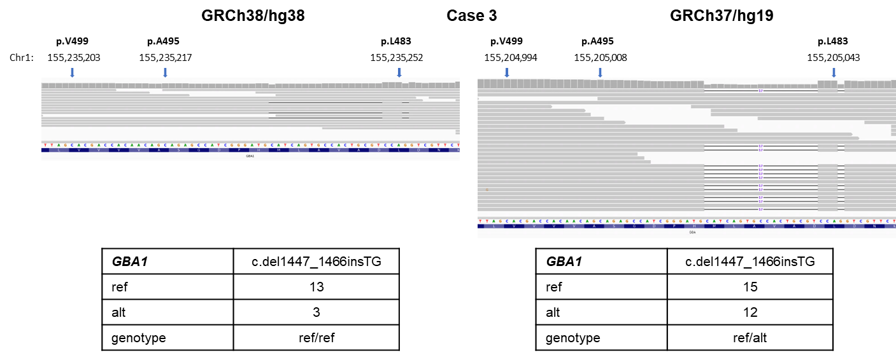

Supplementary Fig. 1 Alignments of short reads to GBA1 in case 3.
Short-read alignments to GBA1 in case 3 is displayed using IGV (with the mapping quality threshold = 20). The tables below the images of IGV show the allele depth located at the indel retrieved from BAM file at the base positions on chromosome 1 of the reference genomes used for alignment.

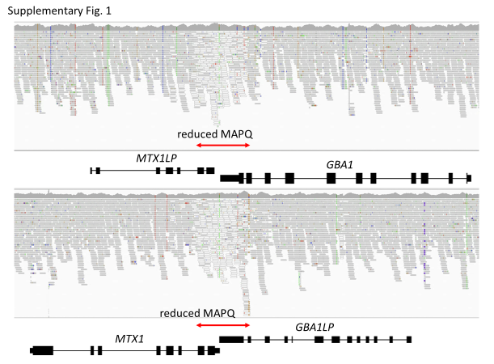
Supplementary Fig. 2 Short reads aligned to the GBA1–MTX1LP and the GBA1LP–MTX1 regions of GRCh38.
The short reads of Case 3 aligned to the GBA1–MTX1LP and the GBA1LP–MTX1 regions of GRCh38 are shown employing IGV (with the mapping quality threshold = 0). The reads with MAPQ = 0 are shown by the bars with white color. The chr1:155,233,639 – chr1:155,235,252 (GRCh38) of GBA1–MTX1LP and chr1:155,213,012 – chr1:155,214,625 (GRCh38) regions of GBA1LP–MTX1 have extraordinarily high identities, resulting in dramatic decrease of MAPQ values.

