**Supplementary Information**

Title:

**Efficient single-channel current measurements of the human BK channel using a liposome-immobilized gold probe**

Journal name:

**Analytical Sciences**

Author names:

**Minako Hirano****\*, Mami Asakura, Toru Ide**

Affiliation

**Graduate School of Interdisciplinary Science and Engineering in Health Systems, Okayama University, 3-1-1 Tsushima-naka, Kita-ku, Okayama-shi, Okayama 700-8530, Japan**

E-mail address of the corresponding author:

**hirano37@okayama-u.ac.jp (Minako Hirano)**

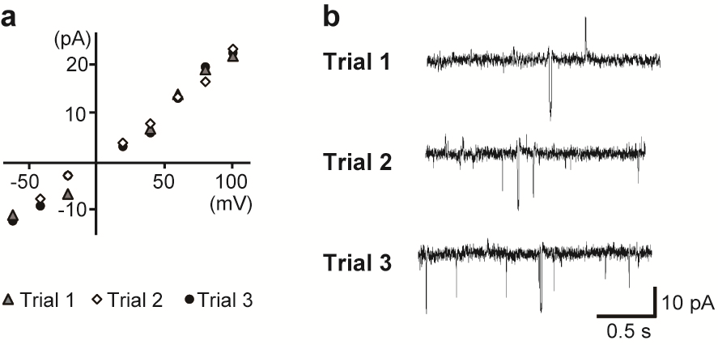

**Figure S1.** Single-channel current recordings of the hBK channel measured multiple times using the probe with hBK channel-containing liposomes ("Probe-hBK-Liposome"). (a) Current-voltage relationships of the hBK channel measured in trial 1, 2, and 3. (b) Typical single-channel current traces of the hBK channel at +80 mV from each measurement.