Stability and Water Solubility of Calcium Ferrite-type Aluminum-rich Phase: Implications for Deep Water Cycle Caused by Subducting Basaltic Crusts

Supporting Information

Xinyue Zhang1,2, Izumi Mashino2, and Takayuki Ishii2*

1 Deep Space Exploration Laboratory / School of Earth and Space Sciences, University of Science and Technology of China, Hefei, Anhui, 230026, China

2 Institute for Planetary Materials, Okayama University, Misasa, Tottori, 682-0193, Japan  
*[takayuki.ishii@okayama-u.ac.jp](mailto:takayuki.ishii@okayama-u.ac.jp))

### Contents of this file

Figures S1-S7

Tables S1 and S2

### Introduction

This supporting information includes the figures and tables helping to understand the manuscript.

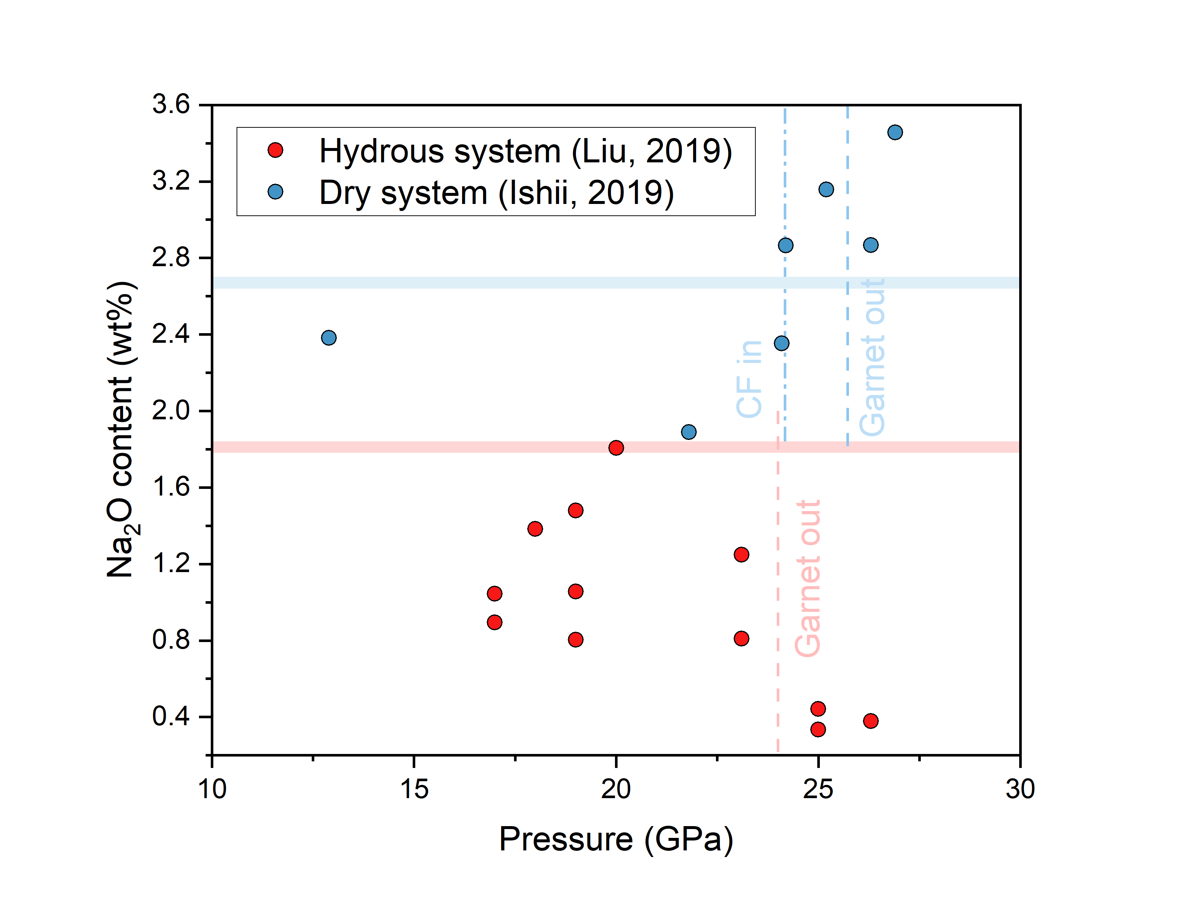

**Figure S1**. Total Na2O contents in the mineral assemblages in hydrous and dry MORB system (Ishii et al. 2019; Liu et al. 2019). The value is calculated by multiplying the Na2O content by the modal fractions of each mineral. The colored bands show the Na2O content in the starting materials.

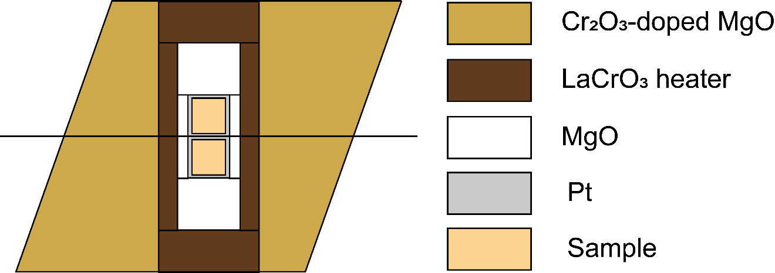

**Figure S2**. An illustration of the cell assembly for high-pressure and high-temperature experiment of 1k3791. The solid line located at the central part and through the octahedral edges is a thermocouple.

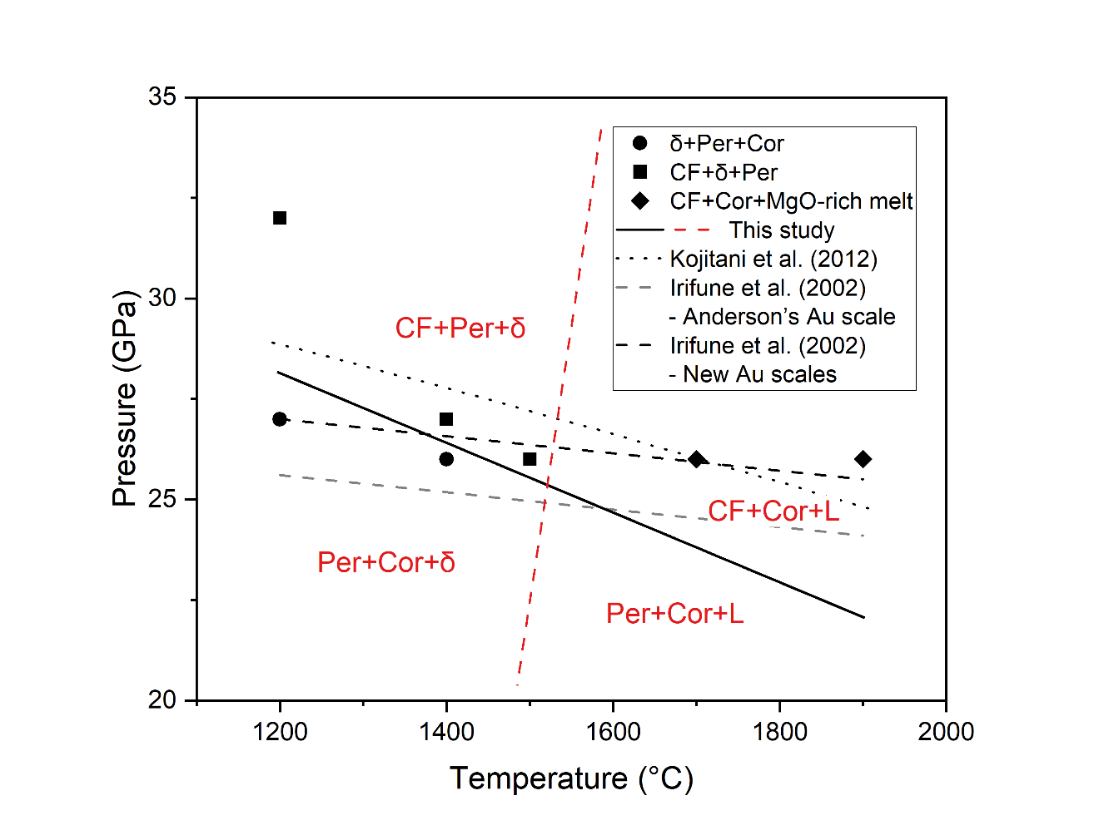**Figure S3**. A phase diagram of CF phase in MgO-Al2O3-5 wt% H2O systems. Solid circles: δ-AlOOH (δ) + periclase (Per) + corundum (Cor); solid squares: CF phase (CF) + δ+ Per; solid diamonds: CF + Cor + MgO rich melt (L); black solid line: a formation boundary of CF determined in this study; grey dashed line: a phase boundary between Per + Cor and CF in MgAl2O4 system from Irifune et al. (2002) with Anderson’s Au pressure scale (Anderson et al. 1989); black dotted line: phase boundaries between Per + Cor and CF from Irifune et al. (2002) with new Au scales (Tsuchiya 2003; Yokoo et al. 2009); black dotted line: a phase boundary between Per + Cor and CF in MgAl2O4 system from Kojitani et al. (2012); red dashed line: an expected boundary between δ + Per and Cor + L.

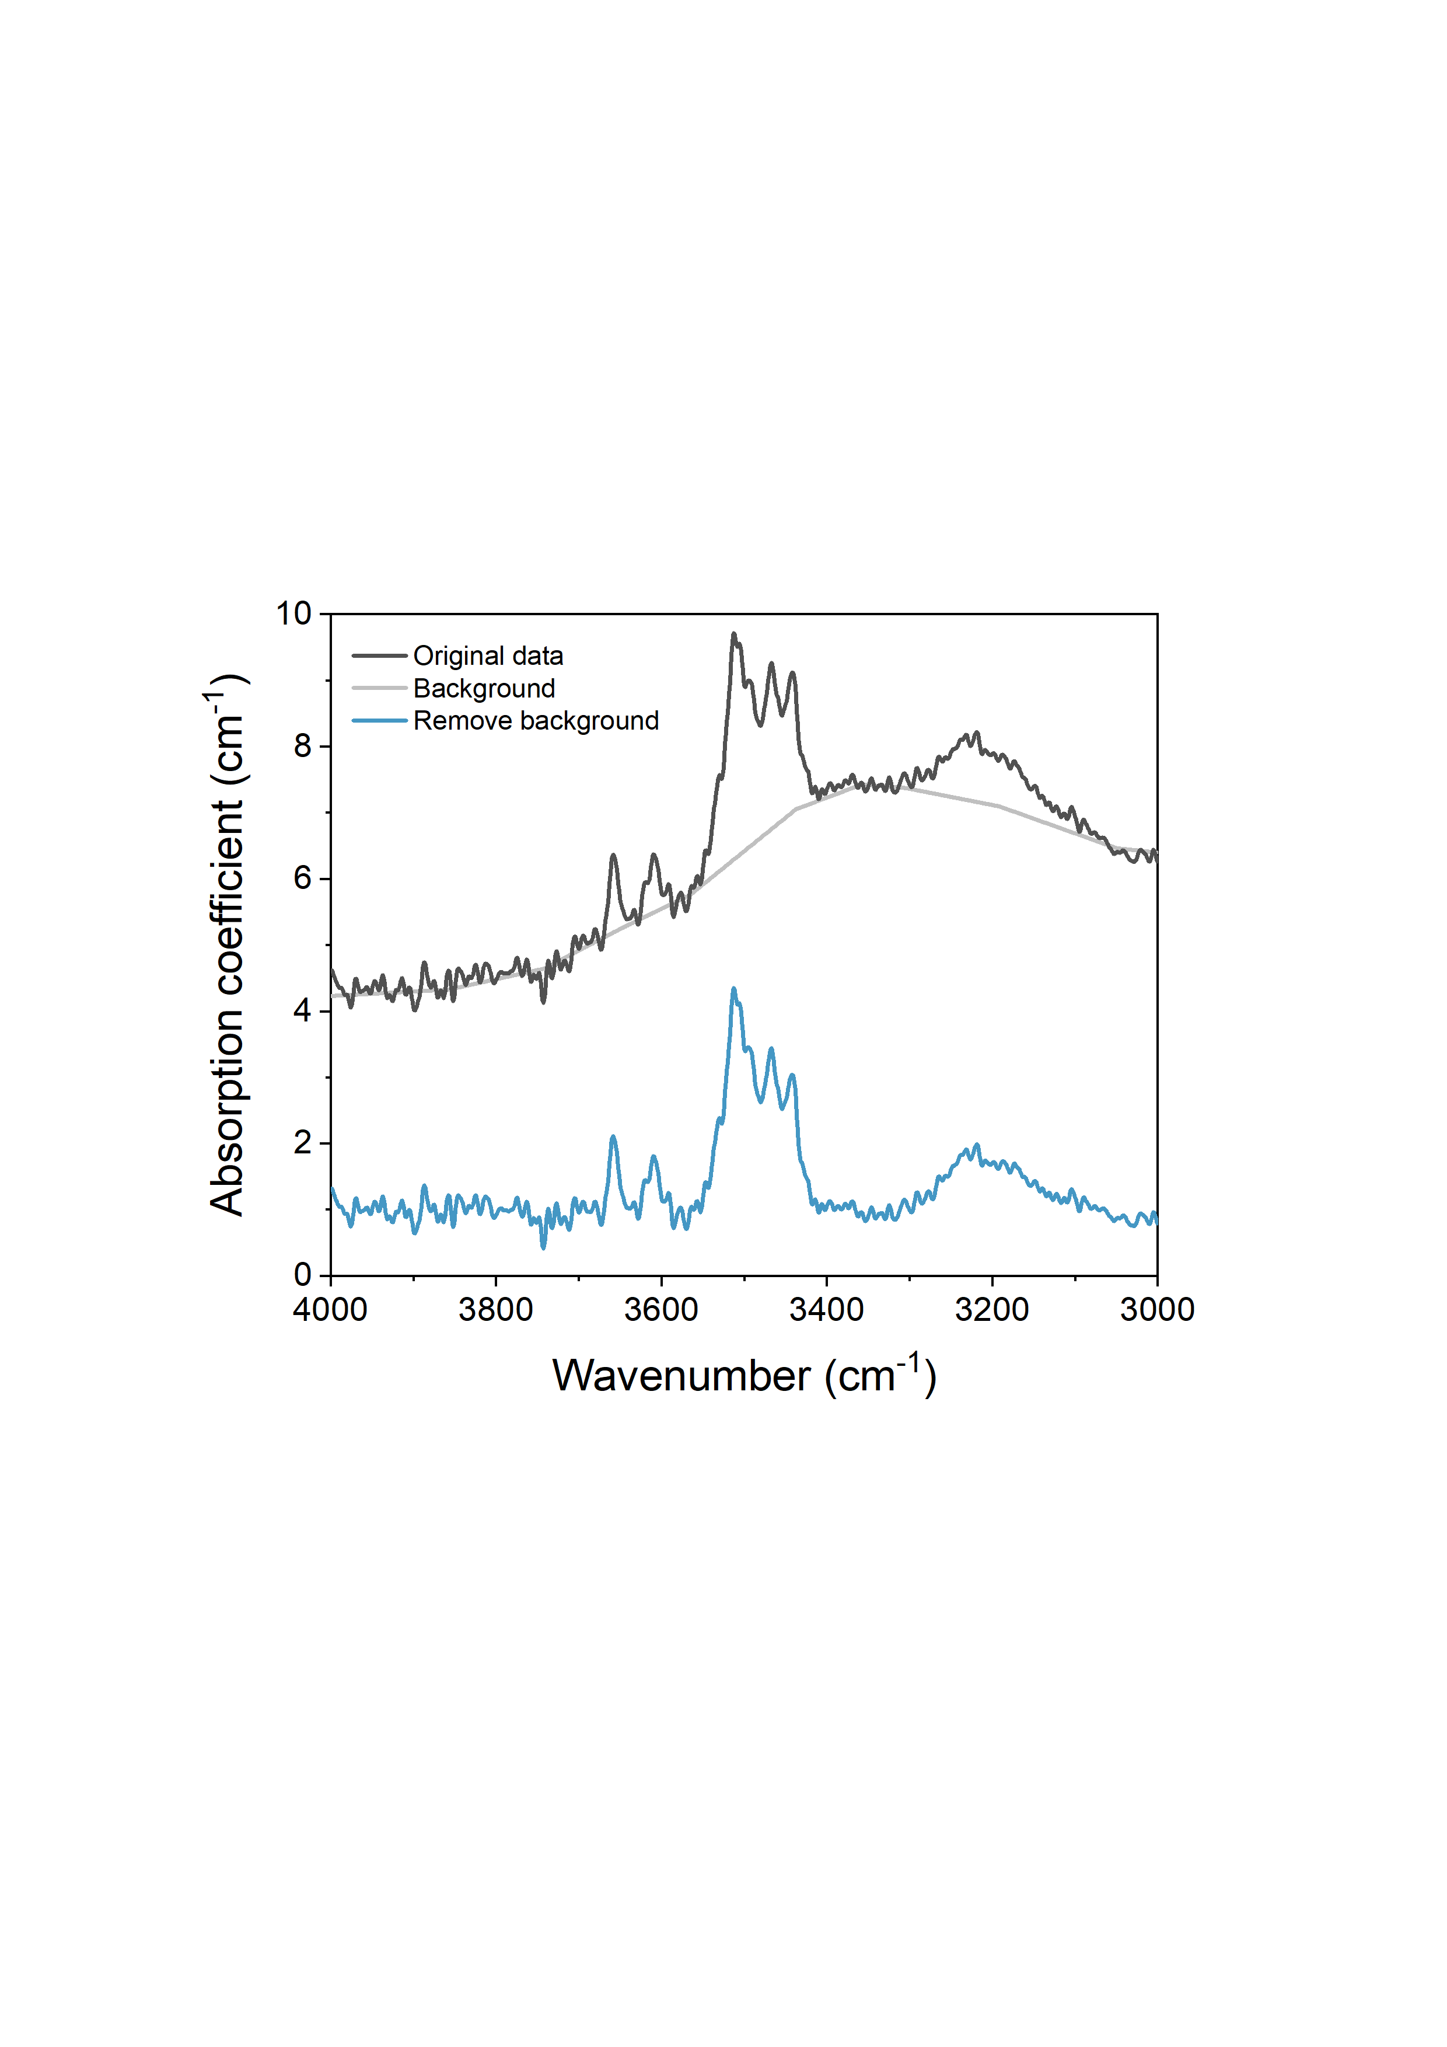

Figure S4. A representative FTIR spectrum of a single crystal synthesized at 1900 °C as an example of baseline subtraction process.

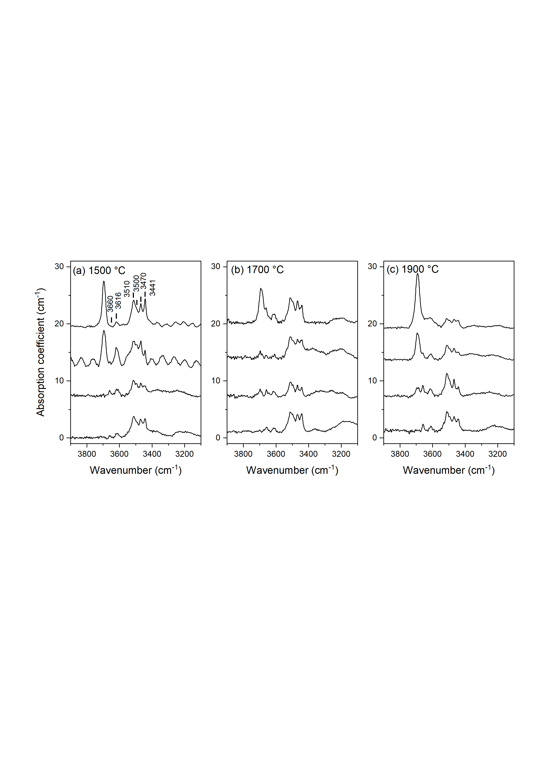

**Figure S5**. Representative unpolarized FTIR spectra of MgAl2O4 CF phase synthesized at 26 GPa and 1500-1900 °C. (a) 1500 °C; (b) 1700 °C; (c) 1900 °C. Each spectrum represents a different single crystal. The baseline has been subtracted and the spectra are normalized to the same thickness.

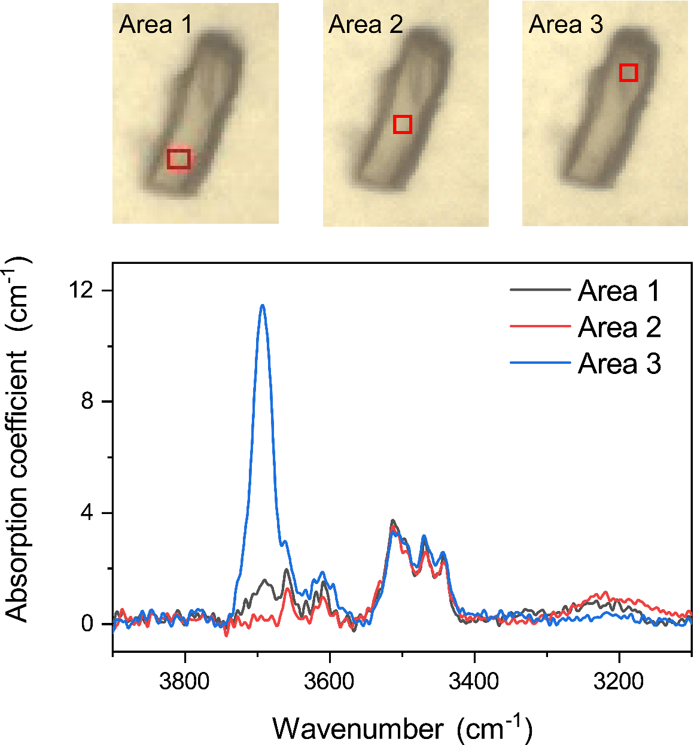

Figure S6. Unpolarized FTIR spectra of different areas within a MgAl2O4 CF phase single crystal synthesized at 26 GPa and 1900 °C. The baseline has been subtracted for each spectrum.

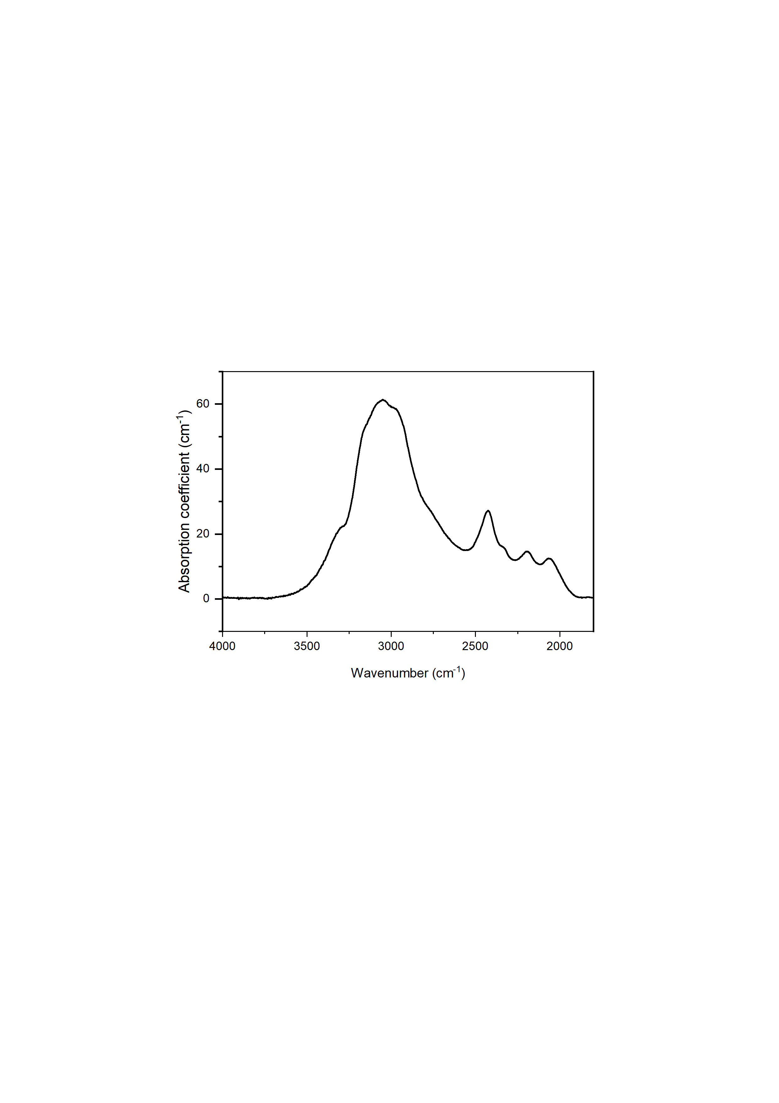

Figure S7. A representative unpolarized FTIR spectrum of corundum single crystal from recovered product synthesized at 26 GPa and 1700 °C. The baseline has been subtracted.

|  |  |  |  |  |  |  |  |  |  |  |  |
| --- | --- | --- | --- | --- | --- | --- | --- | --- | --- | --- | --- |
| Run No. | T (°C) | P (GPa) | SM | Phase | MgO (wt%) | Al2O3 (wt%) | SiO2 (wt%) | Total (wt%) | Mg | Al | Si |
| 1k3791 | 1700 | 26 | 5 | CF | 29.3(2) | 71.4(4) | 0.3(1) | 101.0(5) | 1.025(7) | 1.972(4) | 0.007(2) |
|  |  |  |  | Cor | 0.85(4) | 98.3(2) | 0.13(9) | 99.3(2) | 0.021(1) | 1.982(2) | 0.002(2) |
|  |  |  |  | Per | 97.6(13) | 2.6(11) | 0.10(1) | 100.3(7) | 0.97(1) | 0.02(1) | 0.0006(1) |
|  |  |  |  | L | 31.3(16) | 14.1(7) | 0.42(7) | 45.9(14) |  |  |  |
|  |  |  | 10 | Cor | 0.85(7) | 97.9(3) | 0.16(2) | 98.9(4) | 0.022(2) | 1.981(1) | 0.0027(3) |
|  |  |  |  | Per | 98.8(7) | 0.96(4) | - | 99.8(7) | 0.9882(7) | 0.0076(4) | - |
|  |  |  |  | δ | 1.48(8) | 82.3(9) | 0.38(7) | 84.2(8) | 0.022(1) | 0.980(2) | 0.0039(7) |
|  |  |  |  | L | 35.1(25) | 13.8(7) | 0.28(3) | 49.2(32) |  |  |  |
| 1k3816 | 1900 | 26 | 5 | CF | 28.7(2) | 70.6(2) | 0.09(3) | 99.5(4) | 1.021(5) | 1.983(4) | 0.0020(7) |
|  |  |  |  | Cor | 0.88(1) | 97.39(4) | 0.05(3) | 98.329(5) | 0.0228(3) | 1.9826(5) | 0.0009(5) |
|  |  |  |  | Per | 97.8(11) | 2.0(4) | - | 99.8(6) | 0.975(6) | 0.016(3) | - |
|  |  |  |  | L | 32.3(10) | 6.4(4) | 0.10(2) | 38.8(7) |  |  |  |
| 1k3814 | 1500 | 26 | 5 | CF | 28.5(2) | 70.7(2) | 0.12(4) | 99.3(3) | 1.011(4) | 1.988(4) | 0.0029(9) |
|  |  |  |  | δ | 0.92(8) | 83.8(2) | 0.10(1) | 84.9(2) | 0.014(1) | 0.989(1) | 0.001(1) |
|  |  |  |  | Per | 96.8(9) | 2.9(4) | 0.4(6) | 100.2(7) | 0.960(8) | 0.023(3) | 0.003(4) |
| 1k3801 | 1400 | 26 | 5 | Cor | 0.5(1) | 98.5(1) | 0.2(1) | 99.12(7) | 0.012(3) | 1.988(4) | 0.003(2) |
|  |  |  |  | Per | 99.2(9) | 1.3(5) | - | 100.4(5) | 0.985(6) | 0.010(4) | - |
|  |  |  |  | δ | 0.67(3) | 82.7(3) | 0.09(2) | 83.4(3) | 0.010(1) | 0.992(1) | 0.0009(2) |
| 5k4195 | 1400 | 27 | 5 | CF | 28.5(13) | 70.6(14) | 0.04(4) | 99.1(7) | 1.01(5) | 1.99(3) | 0.0008(8) |
|  |  |  |  | Cor | 0.30(6) | 99.7(5) | 0.05(4) | 100.1(5) | 0.008(1) | 1.993(1) | 0.0009(7) |
|  |  |  |  | Per | 96.3(29) | 4.0(33) | - | 100.3(9) | 0.95(4) | 0.03(3) | - |
|  |  |  |  | δ | 1.1(9) | 83.4(9) | 0.07(5) | 84.6(10) | 0.02(1) | 0.987(9) | 0.0007(5) |
| 5k4199 | 1200 | 27 | 5 | Cor | 0.24(6) | 99.0(9) | 0.04(5) | 99.3(8) | 0.006(1) | 1.995(2) | 0.0006(9) |
|  |  |  |  | Per | 97.0(49) | 3.1(42) | - | 100.1(11) | 0.96(5) | 0.02(3) | - |
|  |  |  |  | δ* | 3.2(10) | 82.4(9) | 0.06(4) | 85.7(10) | 0.05(1) | 0.97(1) | 0.0005(5) |
| 5k4209 | 1200 | 32 | 5 | CF | 29.4(10) | 68.9(9) | 0.15(7) | 98.5(4) | 1.06(4) | 1.96(2) | 0.004(2) |
|  |  |  |  | Per | 100.1(7) | 0.4(1) | - | 100.5(8) | 0.995(1) | 0.0032(9) | - |
|  |  |  |  | δ* | 5.0(10) | 77.8(10) | 0.3(1) | 83.1(10) | 0.08(1) | 0.94(1) | 0.003(1) |

**Note:** The value displayed is the average value of 10 analytical points for CF phase and 2-5 analytical points for other phases.

* The large Mg number observed in the δ-AlOOH phase quenched from 1200 °C is likely attributable to the small grain size of this phase (< 3 μm) in the experimental products.

Table S1. Chemical Compositions of Single Crystals of recovered products at Different Conditions.

|  |  |  |  |
| --- | --- | --- | --- |
| Temperature (℃) | Crystal Number | Thickness (μm) | Water content (ppm wt.) |
| 1500 | 1 | 30 | 97 |
| 2 | 50 | 74 |
| 3 | 30 | 99 |
| 4 | 50 | 80 |
| Average |  | 87(11) |
| 1700 | 1 | 40 | 78 |
| 2 | 35 | 74 |
| 3 | 40 | 96 |
| 4 | 40 | 98 |
| Average |  | 86(11) |
| 1900 | 1 | 65 | 65 |
| 2 | 90 | 71 |
| 3 | 50 | 77 |
| 4 | 40 | 77 |
| Average |  | 73(5) |

Table S2. Information of Single Crystals for FTIR Measurement at each Temperature.

References

Anderson OL, Isaak DG, Yamamoto S (1989) Anharmonicity and the equation of state for gold. J Appl Phys 65(4):1534-1543 doi:10.1063/1.342969

Irifune T, Naka H, Sanehira T, Inoue T, Funakoshi K (2002) In situ X-ray observations of phase transitions in MgAl2O4 spinel to 40 GPa using multianvil apparatus with sintered diamond anvils. Phys Chem Miner 29(10):645-654 doi:10.1007/s00269-002-0275-1

Ishii T, Kojitani H, Akaogi M (2019) Phase relations of Harzburgite and MORB up to the uppermost lower mantle conditions: precise comparison with pyrolite by multisample cell high-pressure experiments with implication to dynamics of subducted slabs. J Geophys Res: Solid Earth 124(4):3491-3507 doi:10.1029/2018jb016749

Kojitani H, Ishii T, Akaogi M (2012) Thermodynamic investigation on phase equilibrium boundary between calcium ferrite-type MgAl2O4 and MgO+α-Al2O3. Phys Earth Planet Inter 212-213:100-105 doi:10.1016/j.pepi.2012.10.002

Liu X, Matsukage KN, Nishihara Y, Suzuki T, Takahashi E (2019) Stability of the hydrous phases of Al-rich phase D and Al-rich phase H in deep subducted oceanic crust. Am Mineral 104(1):64-72 doi:10.2138/am-2019-6559

Tsuchiya T (2003) First‐principles prediction of the P‐V‐T equation of state of gold and the 660‐km discontinuity in Earth's mantle. J Geophys Res: Solid Earth 108(B10) doi:10.1029/2003jb002446

Yokoo M, Kawai N, Nakamura KG, Kondo K-i, Tange Y, Tsuchiya T (2009) Ultrahigh-pressure scales for gold and platinum at pressures up to 550 GPa. Phys Rev B 80(10) doi:10.1103/PhysRevB.80.104114